**A REPORT**

**ON**

**AWS TO AZURE MIGRATION AND VICE-VERSA**

Submitted in partial fulfilment of the requirements

for the award of the Degree of

**Bachelor of Technology**

**of**

**Poornima University, Jaipur**



**Submitted By:**

**KAMLESH CHOUDHARY……………………..2017PUSETBCCX5748**

**LEKHIKA GOSWAMI………………………….2017PUSETBCCX6032**

**HIMALAYA SHARMA………………………….2017PUSETBCCX5805**

**GAURAV SINGH SENGAR…...………………..2017PUSETBCCX5760**

**KHILENDRA SINGH……………………………2017PUSETBCCX5704**

**IIIrd Year, Computer Engineering(CT & IS )**

**Submitted To:**

**Dr. Nitesh Kaushik, Asst. Professor**

**Department of Computer Engineering** **School of Engineering & Technology, Poornima University Ramchandrapura, Sitapura Ext., Jaipur, Rajasthan**

**Session: 2019-20**

**ACKNOWLEDGEMENT**

We have undergone a project development which was meticulously planned and guided at every stage so that it became a life time experience for us. This could not be realized without the help from numerous sources and people in the Poornima University.

We are thankful to **Dr. Manoj Gupta, Pro president, Poornima University** for providing us a platform to carry out this activity successfully.

We are also very grateful to **Mr. Ravi Godara (HOD, Computer Engineering)** for his kind support and guidance.

I would like to take this opportunity to show our gratitude towards **Dr. Nitesh Kaushik & Mr. Tushar Mittal** who helped us in successful completion of my seminar. They have been a guide, motivator & source of inspiration for us to carry out the necessary proceedings for completing this project and related activities successfully and grateful for their guidance and support. We am thankful for their kind support and providing us expertise of the domain to develop the project.

We would also like to express our hearts felt appreciation to all of our friends whom direct or indirect suggestions help us to develop this project and to entire team members for their valuable suggestions.

Lastly, thanks to all faculty members of Department of Computer Engineering for their moral support and guidance.

**KAMLESH CHOUDHARY**

**LEKHIKA GOSWAMI**

**HIMALAYA SHARMA**

**GAURAV SINGH SENGAR**

**KHILENDRA SINGH**

iii

|  |  |
| --- | --- |
|  | **2019-20** |
|  |  |

**Abstract**

AWS and Azure both offer hyperscale, reliable, and secure hosting environments for enterprise workloads in the cloud. Many organizations have already adopted a “cloud first” policy to leverage these benefits and have gone all-in with either AWS or Azure. But what if something changes and a company wants to leave that cloud service provider?  
  
Let us explore some of the use cases where we would migrate data between the two clouds, whether it’s migration from AWS to Azure or an Azure to AWS migration.

**Poornima University, Jaipur** **B.tech, Computer Engineering(CT & IS)**

|  |  |
| --- | --- |
|  | **2019-20** |
|  |  |

**TABLE OF CONTENTS**

|  |  |  |  |
| --- | --- | --- | --- |
| **Cover Page** | |  | **I** |
| **Acknowledgement** | |  | **Ii** |
| **Abstract** |  |  | **Iii** |
| **Table of Contents** | |  | **Iv** |
|  | |  |  |
|  | |  |  |
| **Chapter 1- Introduction………………………………………….** | | **1-2** | |
| 1.1 | Aims and Objectives…………………………………………….………3- | | 4 |
| 1.2 | Scope………………………………………………...…………………4-5 | |  |
| 1.3 | Technology used………………………………………………………5-7 |  | . |
| 1.4 | Technical Requirements………………………………………………7-9. | | . |
| **Chapter 2- About Technology ………………………………11-12** | |  | |
| 2.1 | Introduction ……………………………………………………………11 | |  |
| 2.2 | challenges……………………………………………………………...12 |  |  |
|  |  | |  |
|  |  | |  |
| **Chapter 3- Technological Details/Architecture ……………….13-39** | |  | |
| 3.1 | Implementation aws to azure …..………………………………….13-26 | |  |
|  |  | 10 |  |
| 3.2 | Implementation 2……….………………………………….......….. 26-39 | |  |
| 3.3 | Applications & Limitations …………………………………………39 |  | |
|  |  |  | |
| **Chapter 4-Miscellaneous, Conclusion & Future scope……………..40** | |  | |
| 4.1 | Conclusion…………………………………………………………. | 36 | |
| 4.2 | Future Scope…………………………………………………… | 37 | |

**References……………………………………………………………….**



**Poornima University, Jaipur** **B.tech, Computer Engineering(CT & IS)**

|  |  |
| --- | --- |
|  | **2019-20** |
|  |  |

**Chapter 1**

**Introduction**

* 1. **Aims and Objective:**

## Why Move from One Cloud to Another?

There are a number of reasons why a company would move from AWS to Azure or vice versa. In fact, before beginning a migration, some organizations looking ahead even require a transition-out plan as part of their cloud adoption strategies in case they ever need to move from their first cloud of choice.  
  
Reasons why users in Azure or AWS would want to switch to the competing cloud service provider include:  
  
**1. Changes in the terms and conditions**: Initial cloud adoption for enterprises often depends on a unique value proposition offered by a vendor. However, changes in the terms and conditions of a cloud service provider over time could lead to cloud lock-in concerns for organizations.  
  
**2. Application portability**: Another example of cloud lock-in possibility is the use of heterogeneous platforms used by different cloud vendors which can affect application portability. For example, workloads that use AWS community-contributed Amazon Machine Images (AMIs) or applications configured to make Amazon S3 API calls might limit the ability for enterprises to use other services outside of AWS. In such a case, it might be desirable to migrate out. Another lock-in example is how [Azure Site Recovery](https://cloud.netapp.com/blog/asr-migration-draas-solution) provides automated mechanisms for moving workloads from AWS to Azure, but requires multiple complex manual steps or third-party tools to migrate in the opposite direction.  
  
**3. Contract renewal**: Organizations often reevaluate hosting options during the contract renewal period to explore differentiating features offered by competing service providers. With new products and features being introduced by cloud service providers, customers have more choices than ever before to choose an optimal hosting platform for their applications.  
  
**4. Cost-benefits**: Services offered at premium rates by one service provider could be available at competitive rates with a different provider. For example, [Azure Hybrid Benefit](https://azure.microsoft.com/en-in/pricing/hybrid-benefit/) along with reserved instances can provide up to 80% cost saving and offers a great value proposition for organizations with pre-existing investments in Microsoft licenses. AWS, on the other hand, provides [Microsoft Licensing on AWS](https://aws.amazon.com/windows/resources/licensing/), in which customers can use their Microsoft licenses with or without [Software Assurance](https://www.microsoft.com/en-us/licensing/licensing-programs/software-assurance-default.aspx) to reduce cloud hosting charges.  
  
**5. Compliance standards**: [The compliance standards](https://cloud.netapp.com/blog/data-compliance-regulations-hipaa-gdpr-and-pci-dss) to be met for hosting data and application with a cloud service provider or on-premises varies across different industry sectors. Any instance of non-compliance flagged during an audit could lead to re-hosting or migration of application/data to a compliant platform.  
  
**6. Data consolidation**: In hybrid cloud architectures, a company’s data could exist across public/private clouds or on-premises deployments. Consolidation of data and seamless management is important for optimizing the spend on data storage and operations. One example of this is in the case of M&A (Mergers & acquisitions), where companies with different platforms need to consolidate.

**1.2 Scope:**

**Point-to-Site** (VPN over SSTP) configurations let you connect from a single computer from anywhere to anything located in your virtual network. It uses the Windows in-box VPN client. As part of the Point-to-Site configuration, you install a certificate and a VPN client configuration package, which contains the settings that allow your computer to connect to any virtual machine or role instance within the virtual network. It's great when you want to connect to a virtual network, but aren't located on-premises. It's also a good option when you don't have access to VPN hardware or an externally facing IPv4 address, both of which are required for a Site-to-Site connection.

You can configure your virtual network to use both Site-to-Site and Point-to-Site concurrently, as long as you create your Site-to-Site connection using a route-based VPN type for your gateway. Route-based VPN types are called dynamic gateways in the classic deployment model.

* 1. **Technology used**

**Microsoft Azure** is a [cloud computing](https://en.wikipedia.org/wiki/Cloud_computing) service created by [Microsoft](https://en.wikipedia.org/wiki/Microsoft) for building, testing, deploying, and managing applications and services through Microsoft-managed [data centers](https://en.wikipedia.org/wiki/Data_center). It provides [software as a service (SaaS)](https://en.wikipedia.org/wiki/Software_as_a_service), [platform as a service (PaaS)](https://en.wikipedia.org/wiki/Platform_as_a_service) and [infrastructure as a service (IaaS)](https://en.wikipedia.org/wiki/Infrastructure_as_a_service) and supports many different [programming languages](https://en.wikipedia.org/wiki/Programming_language), tools, and frameworks, including both Microsoft-specific and third-party software and systems.

**PROJECT TECHNOLOGY :**

# About Azure Migrate

This article provides a quick overview of the Azure Migrate service.

Azure Migrate provides a centralized hub to assess and migrate to Azure on-premises servers, infrastructure, applications, and data.

Azure Migrate provides the following features:

* **Unified migration platform**: A single portal to start, run, and track your migration to Azure.
* **Range of tools**: A range of tools for assessment and migration. Tools include Azure Migrate: Server Assessment and Azure Migrate: Server Migration. Azure Migrate integrates with other Azure services and with other tools and independent software vendor (ISV) offerings.
* **Assessment and migration**: In the Azure Migrate hub, you can assess and migrate:
  + **Servers**: Assess on-premises servers and migrate them to Azure virtual machines.
  + **Databases**: Assess on-premises databases and migrate them to Azure SQL Database or to an Azure SQL Database managed instance.
  + **Web applications**: Assess on-premises web applications and migrate them to Azure App Service by using the Azure App Service Migration Assistant.
  + **Virtual desktops**: Assess your on-premises virtual desktop infrastructure (VDI) and migrate it to Windows Virtual Desktop in Azure.
  + **Data**: Migrate large amounts of data to Azure quickly and cost-effectively using Azure Data Box products

AWS Server Migration Service automates the migration of your on-premises VMware vSphere, Microsoft Hyper-V/SCVMM, and Azure virtual machines to the AWS Cloud. AWS SMS incrementally replicates your server VMs as cloud-hosted Amazon Machine Images (AMIs) ready for deployment on Amazon EC2. Working with AMIs, you can easily test and update your cloud-based images before deploying them in production.

By using AWS SMS to manage your server migrations, you can:

* **Simplify the cloud migration process.** You can begin migrating a group of servers with just a few clicks in the AWS Management Console. After the migration has initiated, AWS SMS manages all the complexities of the migration process, including automatically replicating volumes of live servers to AWS and creating new AMIs periodically. You can quickly launch EC2 instances from AMIs in the console.
* **Orchestrate multi-server migrations.** AWS SMS orchestrates server migrations by allowing you to schedule replications and track progress of a group of servers that constitutes an application. You can schedule initial replications, configure replication intervals, and track progress for each server using the console. When you launch a migrated application, you can apply customized configuration scripts that run during startup.
* **Test server migrations incrementally:** With support for incremental replication, AWS SMS allows fast, scalable testing of migrated servers. Because AWS SMS replicates incremental changes to your on-premises servers and transfers only the delta to the cloud, you can test small changes iteratively and save on network bandwidth.
* **Support the most widely used operating systems.** AWS SMS supports the replication of operating system images containing Windows, as well as several major Linux distributions.
* **Minimize downtime.** Incremental AWS SMS replication minimizes the business impact associated with application downtime during the final cutover.

Use of AWS SMS is limited as follows:

* 50 concurrent VM migrations per account, unless a customer requests a limit increase.
* 90 days of service usage per VM (not per account), beginning with the initial replication of a VM. We terminate an ongoing replication after 90 days unless a customer requests a limit increase.
* 50 concurrent application migrations per account, with a limit of 10 groups and 50 servers in each application.

## Pricing

There is no additional fee to use Server Migration Service. You pay the standard fees for the S3 buckets, EBS volumes, and data transfer used during the migration process, and for the EC2 instances that you run. For more information, see [AWS Server Migration Service pricing](http://aws.amazon.com/server-migration-service/pricing/)

**Trust Factor :**

### Microsoft invests more than ****USD 1 billion annually**** on cyber security research and development

### Azure employ more than ****3,500 security experts**** completely dedicated to your data security and privacy.

### Azure has ****more compliance certifications**** than any other cloud provider.

* 1. **General Requirements**

## General Requirements

Before setting up AWS SMS, take action as needed to meet all of the following requirements.

**All VMs**

* Disable any antivirus or intrusion detection software on the VM you are migrating. These services can be re-enabled after the migration process is complete.
* Disconnect any CD-ROM drives (virtual or physical) connected to the VM.

**Windows VMs**

* Enable Remote Desktop (RDP) for remote access.
* Install the appropriate version of .NET Framework on the VM. Note that .NET Framework 4.5 or later will be installed automatically on your VM if required.

|  |  |
| --- | --- |
| **Windows Version** | **.NET Framework Version** |
| Windows Server 2008 or earlier | 3.5 or later |
| Windows Server 2008 R2 or later | 4.5 or later |
| Windows 8 or earlier | 3.5 or later |
| Windows 8.1 or later | 4.5 or later |

* When preparing a Microsoft Windows VM for migration, configure a fixed pagefile size and ensure that at least 6 GiB of free space is available on the root volume. This is necessary for successful installation of the drivers.
* Make sure that your host firewall (such as Windows firewall) allows access to RDP. Otherwise, you will not be able to access your instance after the migration is complete.
* Apply the following hotfixes:
  + [You cannot change system time if RealTimeIsUniversal registry entry is enabled in Windows](https://support.microsoft.com/en-us/help/2922223/you-cannot-change-system-time-if-realtimeisuniversal-registry-entry-is-enabled-in-windows)
  + [High CPU usage during DST changeover in Windows Server 2008, Windows 7, or Windows Server 2008 R2](https://support.microsoft.com/en-us/help/2800213/high-cpu-usage-during-dst-changeover-in-windows-server-2008,-windows-7,-or-windows-server-2008-r2.)

**Linux VMs**

* Enable Secure Shell (SSH) for remote access.
* Make sure that your host firewall (such as iptables) allows access to SSH. Otherwise, you will not be able to access your instance after the migration is complete.
* Make sure that your Linux VM uses GRUB (GRUB legacy) or GRUB 2 as its bootloader.
* Make sure that the root volume of your Linux VM uses one of the following file systems:
  + EXT2
  + EXT3
  + EXT4
  + Btrfs
  + JFS
  + XFS

**Programmatic Modifications to VMs**

When importing a VM, AWS modifies the file system to make the imported VM accessible to the customer. The following actions may occur:

* [Linux] Installing Citrix PV drivers either directly in OS or modify initrd/initramfs to contain them.
* [Linux] Modifying network scripts to replace static IP addresses with dynamic IP addresses.
* [Linux] Modifying /etc/fstab, commenting out invalid entries and replacing device names with UUIDs. If no matching UUID can be found for a device, the nofail option is added to the device description. You will need to correct the device naming and remove nofail after import. As a best practice when preparing your VMs for import, we recommend that you specify your VM disk devices by UUID rather than device name.

Entries in /etc/fstab that contain distributed file system types (nfs, cifs, smbfs, vboxsf, sshfs, etc.) will be disabled.

* [Linux] Modifying grub bootloader settings such as the default entry and timeout.
* [Windows] Modifying registry settings to make the VM bootable

**Poornima University, Jaipur** **B.tech, Computer Engineering(CT & IS)**

**Chapter 2**

**About Technology**

**2.1 Introduction**

# About Azure Migrate

This article provides a quick overview of the Azure Migrate service.

Azure Migrate provides a centralized hub to assess and migrate to Azure on-premises servers, infrastructure, applications, and data.

Azure Migrate provides the following features:

* **Unified migration platform**: A single portal to start, run, and track your migration to Azure.
* **Range of tools**: A range of tools for assessment and migration. Tools include Azure Migrate: Server Assessment and Azure Migrate: Server Migration. Azure Migrate integrates with other Azure services and with other tools and independent software vendor (ISV) offerings.
* **Assessment and migration**: In the Azure Migrate hub, you can assess and migrate:
  + **Servers**: Assess on-premises servers and migrate them to Azure virtual machines.
  + **Databases**: Assess on-premises databases and migrate them to Azure SQL Database or to an Azure SQL Database managed instance.
  + **Web applications**: Assess on-premises web applications and migrate them to Azure App Service by using the Azure App Service Migration Assistant.
  + **Virtual desktops**: Assess your on-premises virtual desktop infrastructure (VDI) and migrate it to Windows Virtual Desktop in Azure.
  + **Data**: Migrate large amounts of data to Azure quickly and cost-effectively using Azure Data Box products

The Azure Migrate: Server Migration tool helps you migrate to Azure:

* On-premises VMware VMs
* Hyper-V VMs
* Physical servers
* Other virtualized machines
* Public cloud VMs

**2.2 Challenges**

## Cloud Migration Challenges between AWS and Azure

Data is the nexus of enterprise IT, and migration from AWS to Azure and vice versa is one of the most challenging aspects when implementing multicloud architectures. Let’s look at some of the challenges.  
  
**1. Data Migration**: The fact that AWS and Azure use proprietary storage offerings and APIs make the data migration process complex. Leveraging third party tools for data transfer could lead to integration challenges as both the platforms use diverse technologies in the backend. And the entire process of transitioning between the two clouds may not be a feasible option for business-critical applications due to time and cost constraints involved.  
  
**2. Secure Data Transfer**: Secure transfer of data between AWS and Azure should be done using a process that meets industry-specific governance and compliance standards. Direct download and upload of data can lead to security concerns as the data at rest and in transit should always be encrypted. While Azure Site Recovery offers a feasible solution for large scale secure migration between AWS and Azure, it requires additional infrastructure to be set up in AWS, which may not be feasible in cost-sensitive environments.  
  
**3. Access Control Privileges**: When data is migrated between AWS and Azure platforms, administrators need to ensure that consistent data access and protection policies are applied in the destination as well. Security and access control are configured using different sets of tools and policies in AWS and Azure. While AWS depends on IAM user policies and resource-based policies for Amazon S3 access, Azure storage uses RBAC assigned to Azure AD users. Hence, redesign and reconfiguration of the entire system might be required to maintain the same level of security after migration. Management of data across AWS and Azure environments using unified tools and interfaces is also a major challenge.  
  
**4. Other Challenges**: There are a few other additional challenges to the migration process between platforms. It will be necessary to find a way to evaluate the costs and calculate the differences. You’ll also need a way to measure and maintain the same or acceptable performance and SLAs of different devices, instances, VMs, storage types, etc. on the new platform.

Poornima University, Jaipur B.Tech, Computer Engineering

|  |  |
| --- | --- |
|  | **2019-20** |
|  |  |

**Chapter 3**

**Technological Details/Architecture**

**3.1 implementation aws to azure**

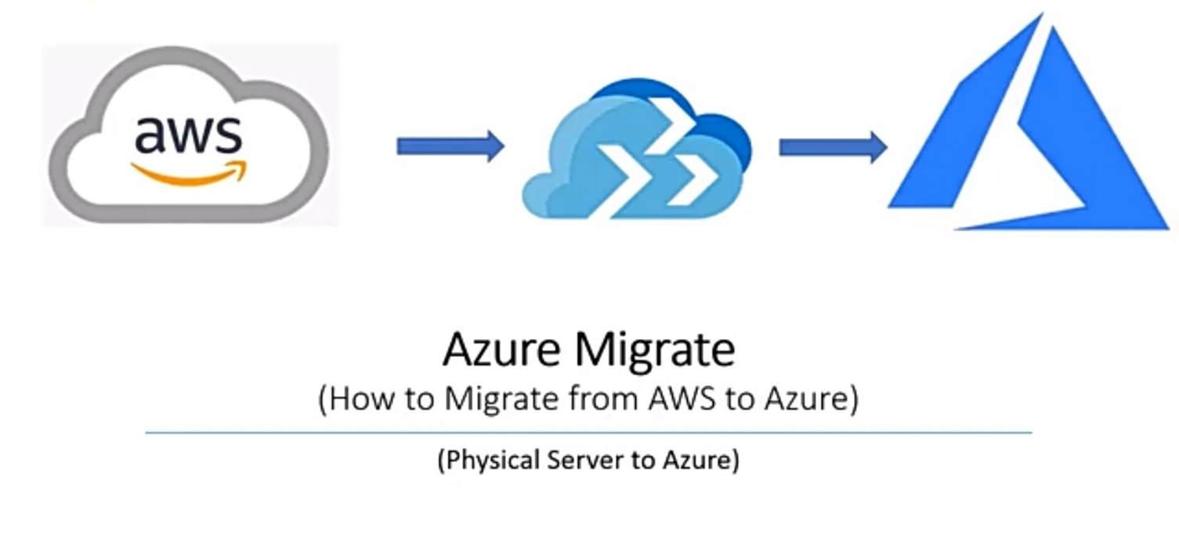

## How to Setup an Azure Migrate Project

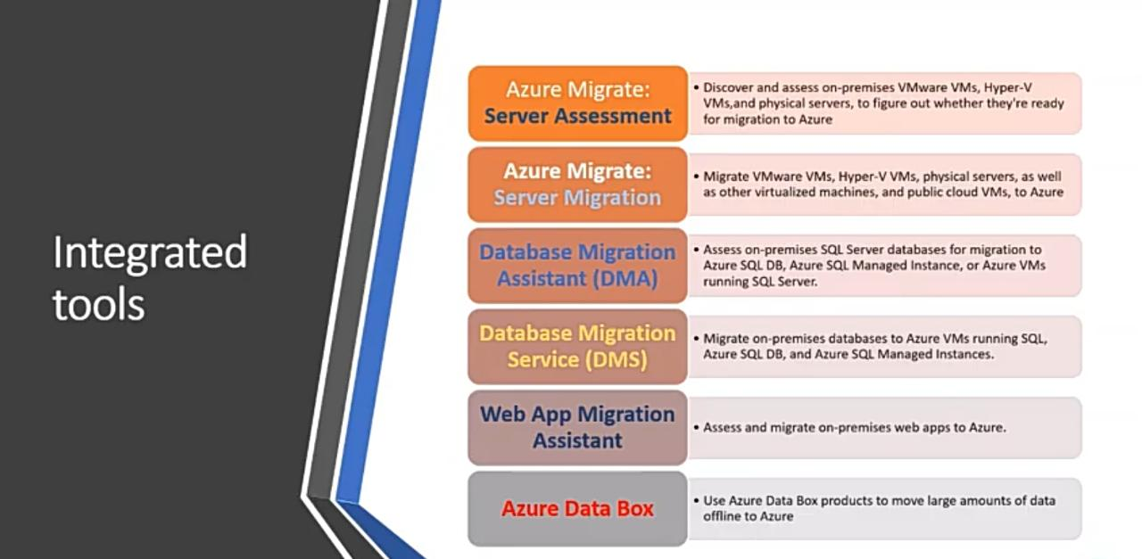

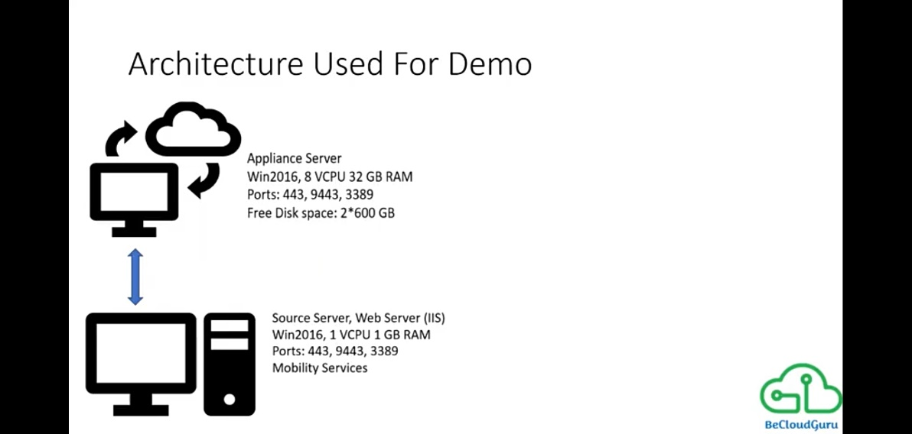

1.First, we need to set up an Azure Migrate project. Once logged into the Azure Portal search for the Azure Migrate service and select **Assess and migrate servers**:

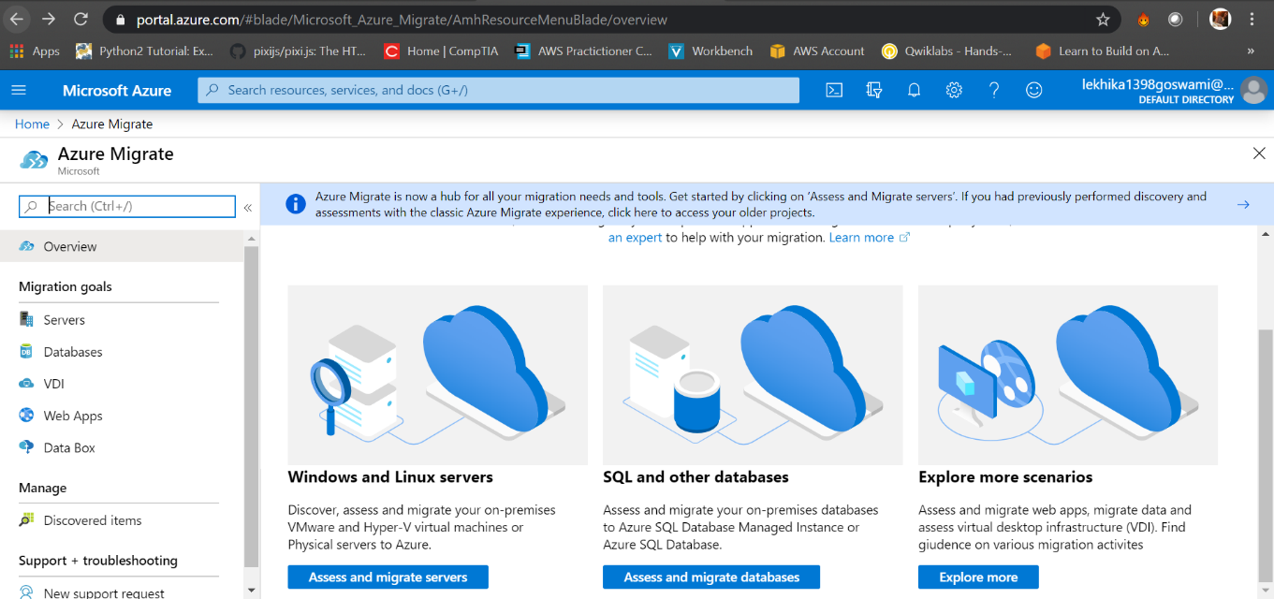

2.Now choose choose access and migrate servers

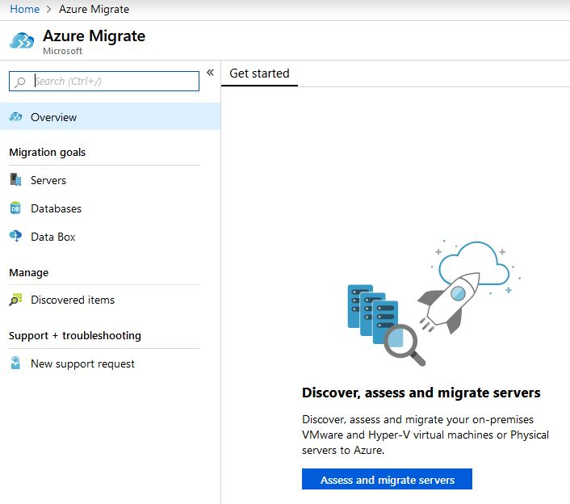

3.Create the Migration Project by filling in the details such as resource group and subscription. Then select**Select migration tool** tab:

4.Select **Azure Migrate: Server Migration**and select **Review + add tool(s)**and click **Add Tools:**

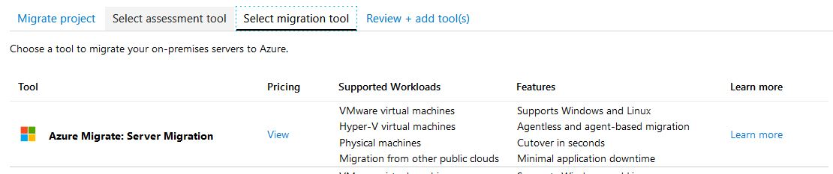

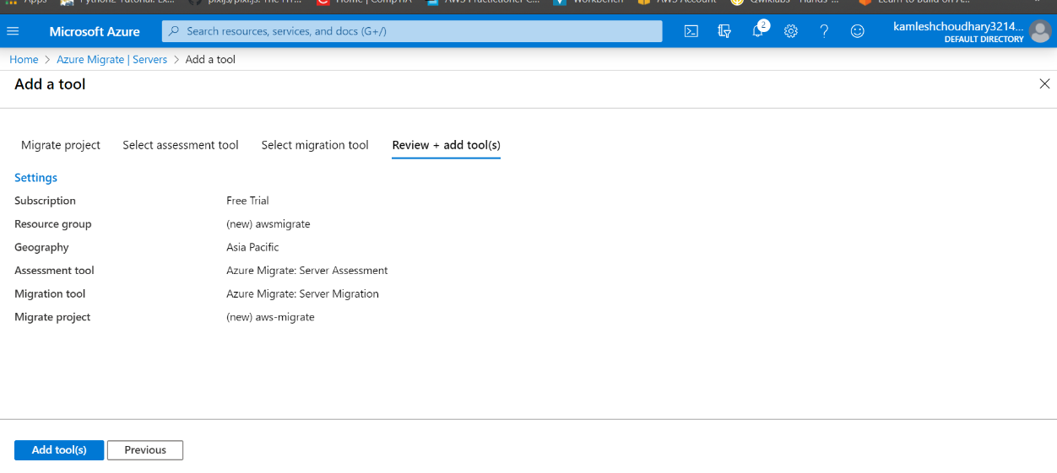

5.Now our Migration Project has been created.

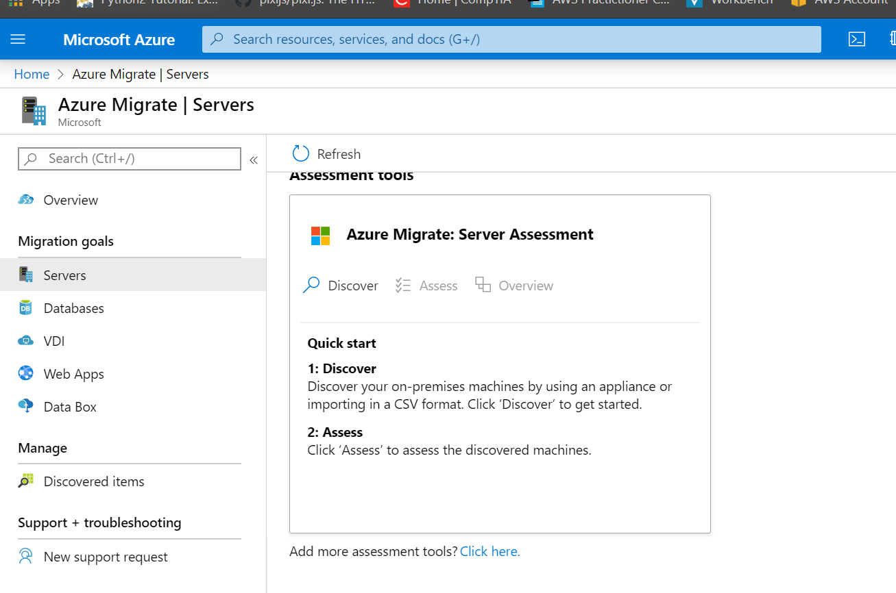

6.Now in migration tools select discover. Choose the option valid to your requirement. Here we are choosing non virtualized.

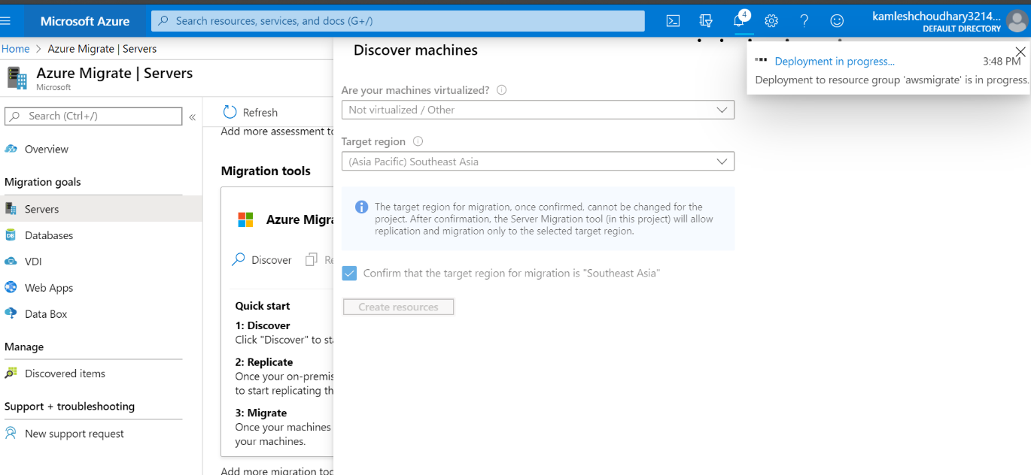

7.After deployment it will ask you to choose between a installing a new replication or scale out the previous one.here we will use the new replication because we have no instances deployed before.

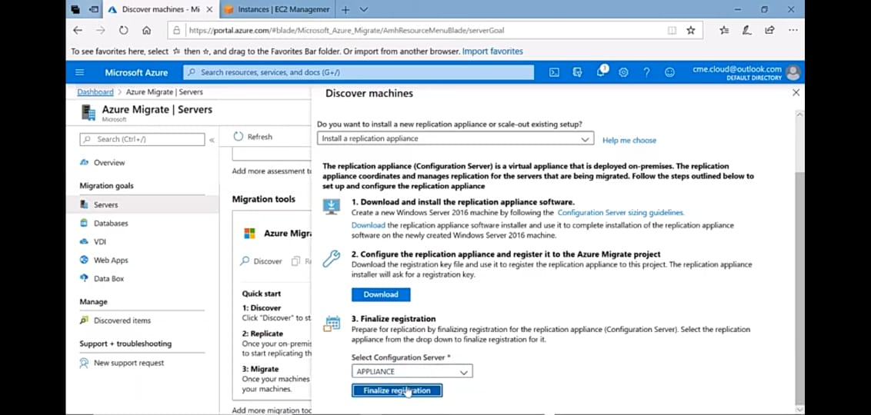

8.now it will ask to to download a replication software and a key to access it.

Download and run this software in you appliance which we created in aws.

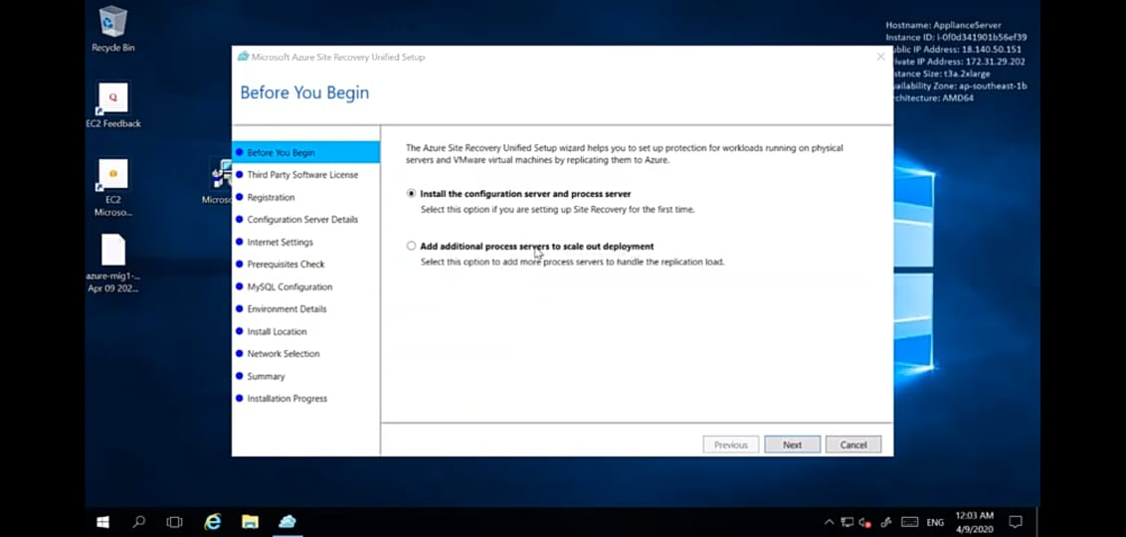

9. now it will ask for connection.

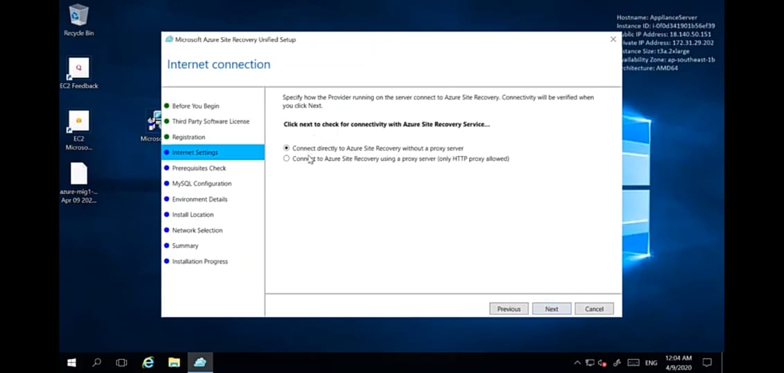

10.it will run the prerequisites check.

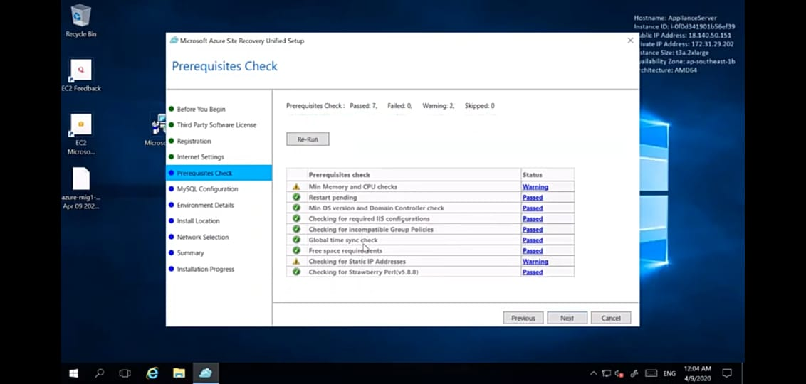

11.put a password and click next.

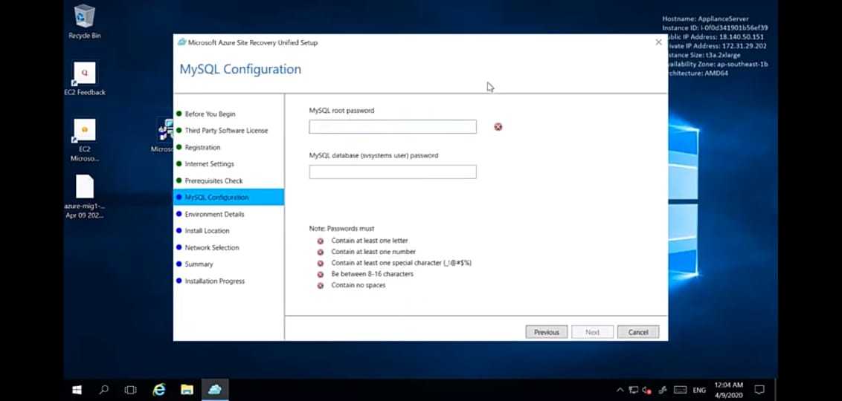

12.click yes or no .here I choose no and click next.

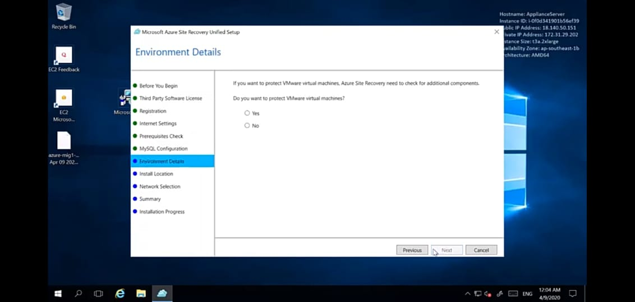

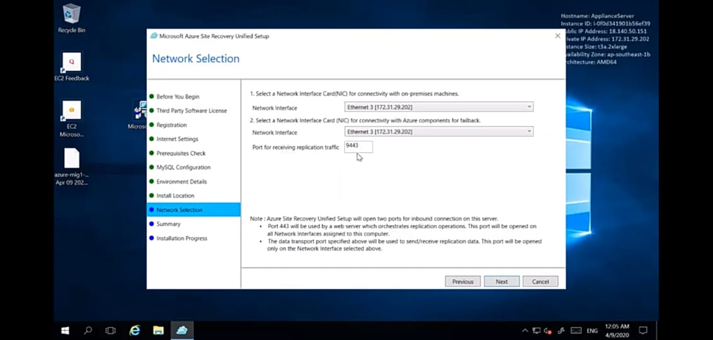

13.click install and a few services get installed.

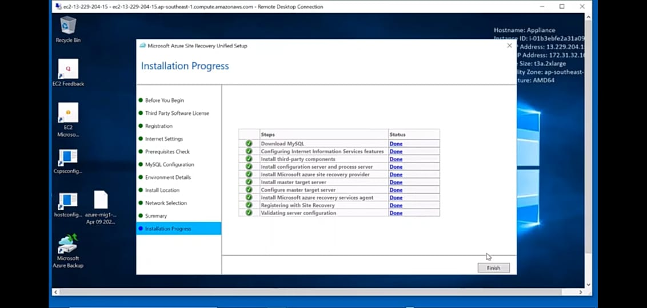

14.restart the server.

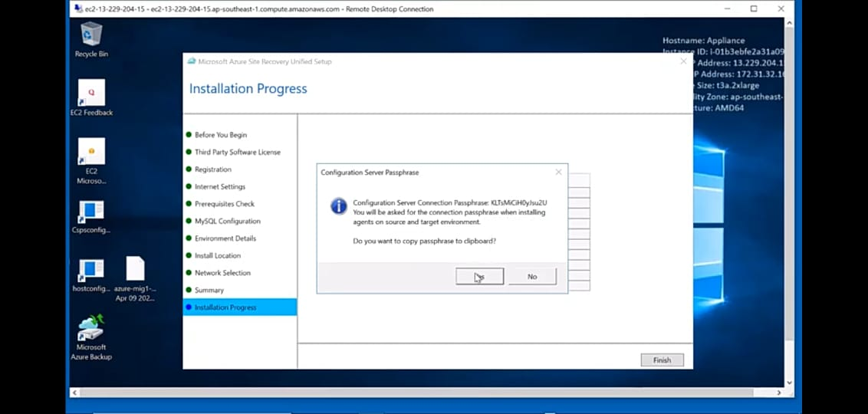

15.Enter username and password. Go to vault registration

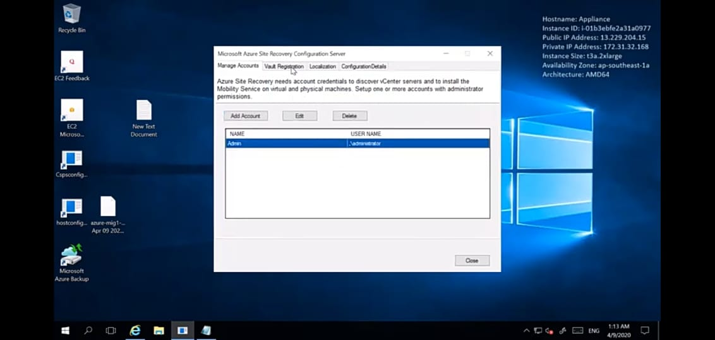

16.click register.

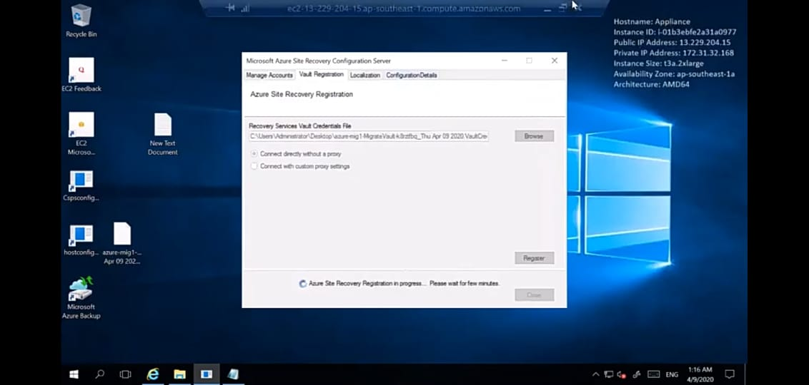

15.Get the source file from ASR \home\pushinstall\repository.also you can directly acces it from your downloads.

16.now copy this file and paste to thw webserver,and install.

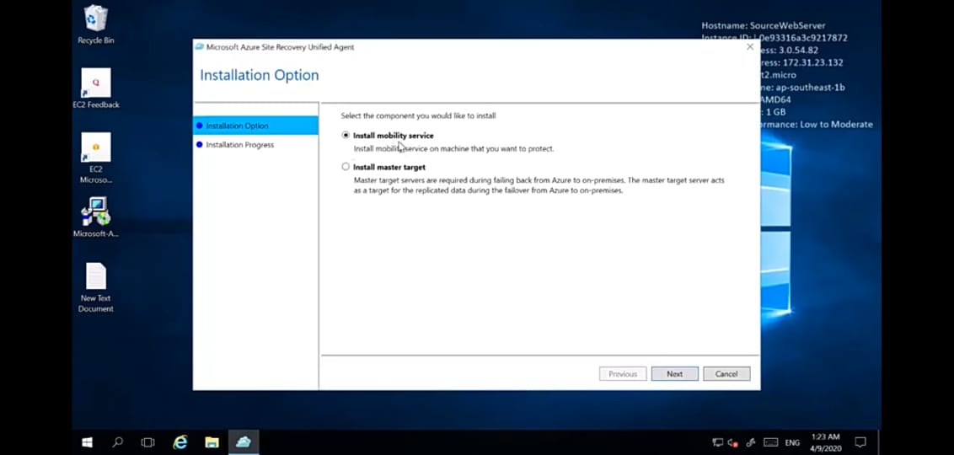

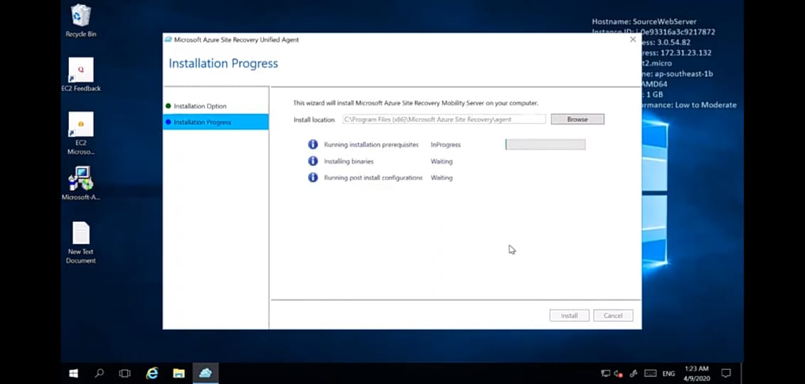

17.copy and paste the ip address of the server.

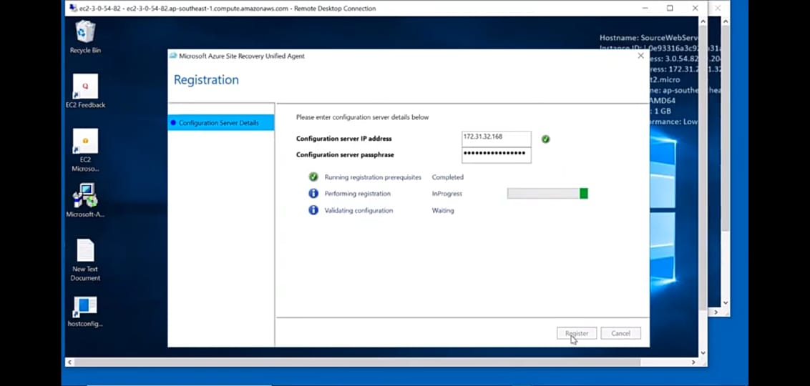

18.click register. After this go to azure portal and finalize the registration.

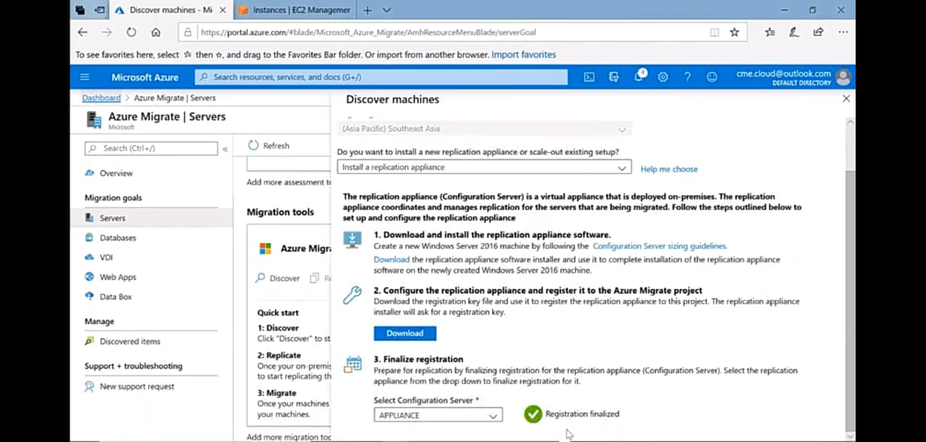

## How to Start Replication with Azure Migrate

Once the discovery is done we can start replicating our VM over to Azure. In the Azure Portal under our Azure Migrate project, we will see a “Replicate” option appear.

Select **Replicate:**

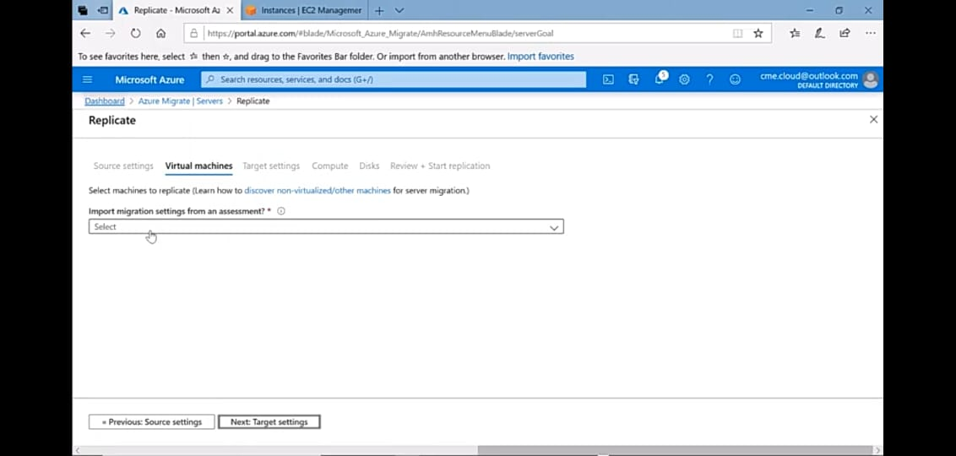

Now folo the steps and click next.

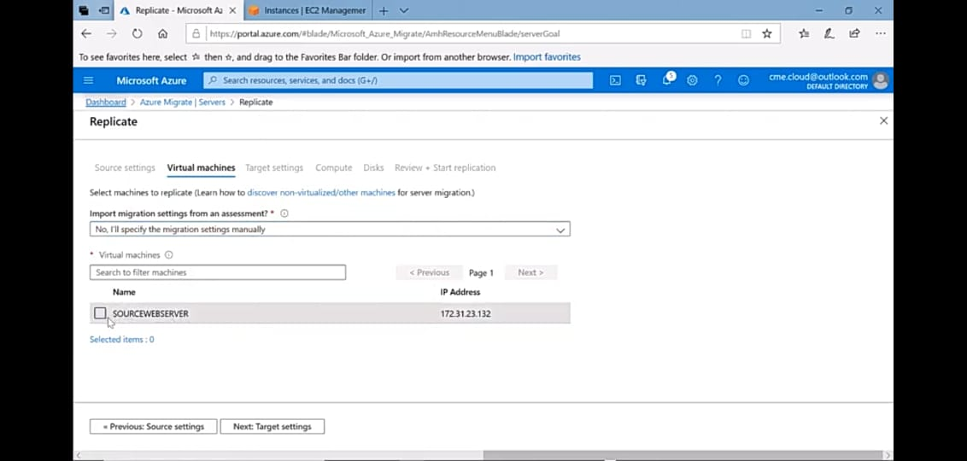

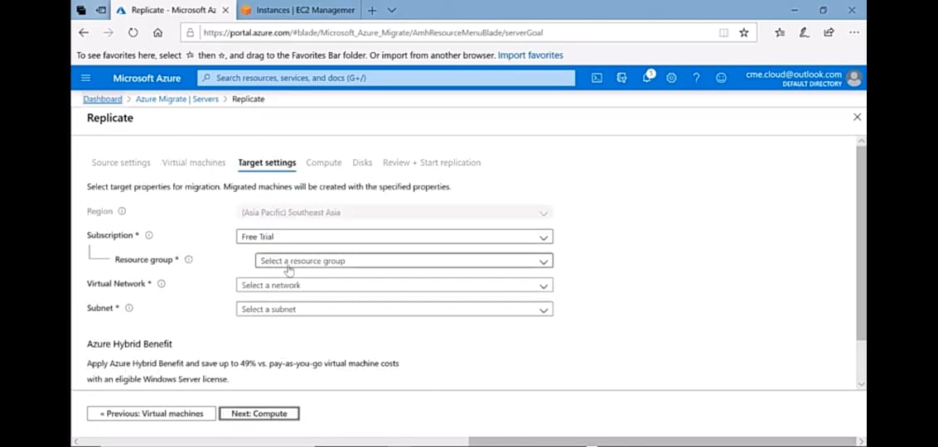

Choose the type of disks you want.

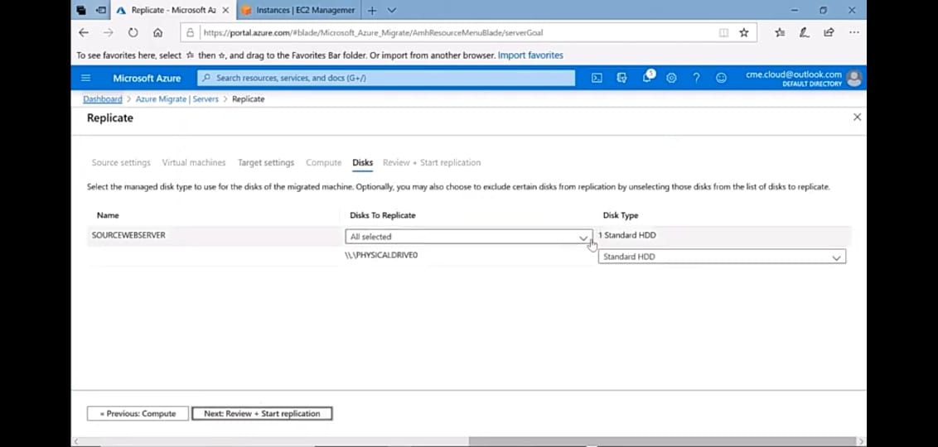

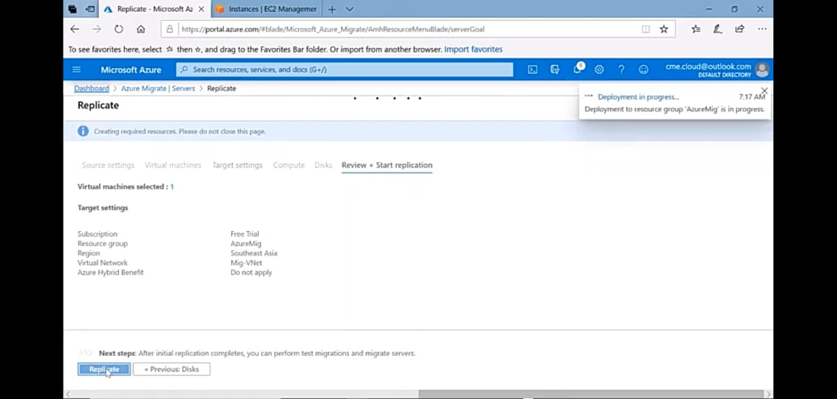

After this you will be able to check the status of replicating servers.

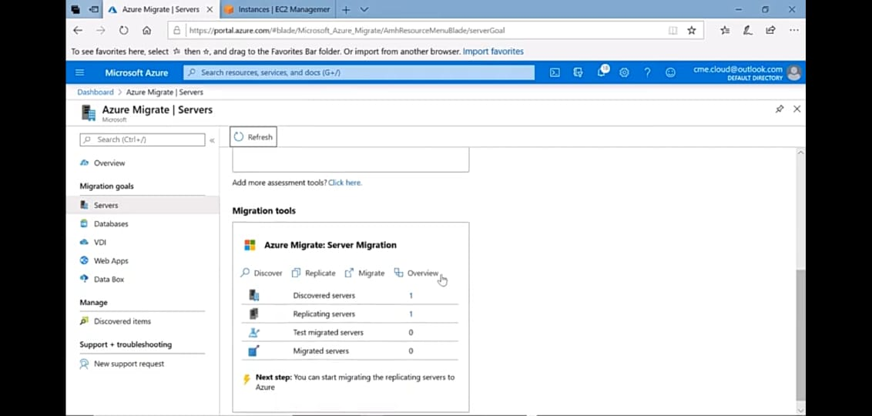

After this go to migrate option in migration tools in azure portal.

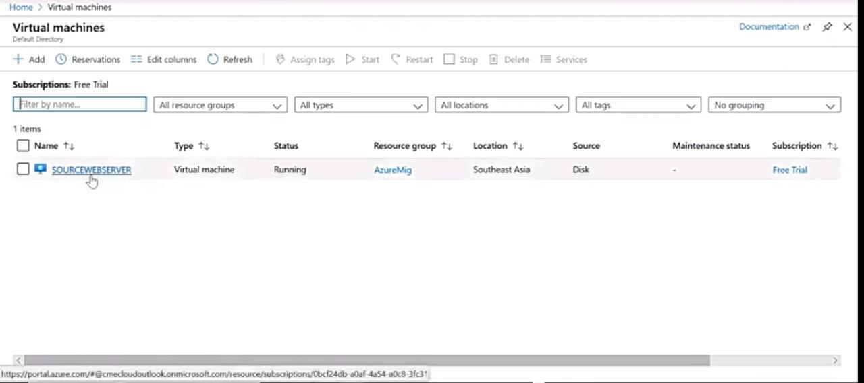

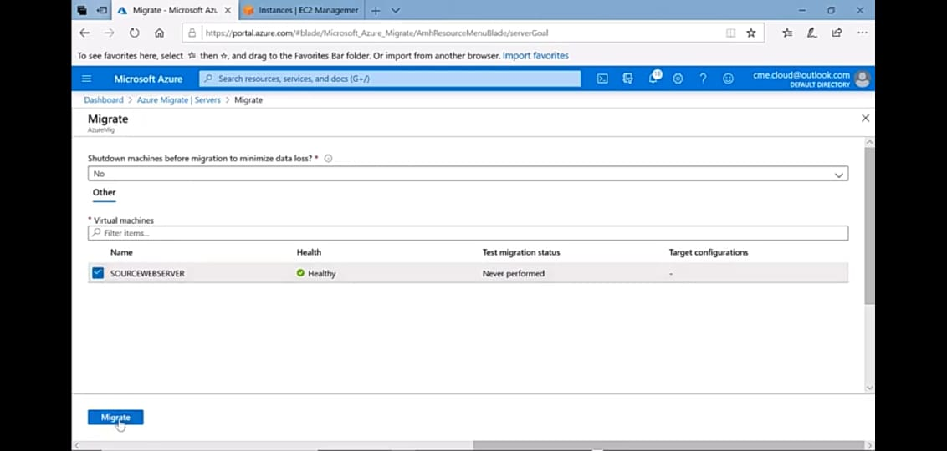

**Now after some time you will se the server has ben migrated**

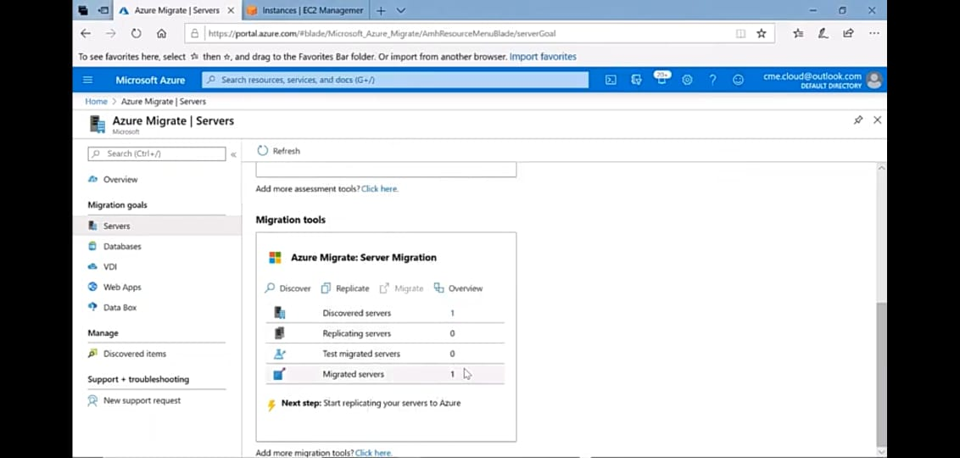

## How to Run an Azure Migrate Test Migration

Microsoft recommends running a test migration before migrating any VM over to Azure. The test migration does not affect the on premise VM, It simply deploys a VM in Azure with the replicated data. Typically you would want to deploy the test to a development network etc. To start a test, inside the Azure Migrate Appliance window click on the name of the serverNow we have this fancy screen that allows us to perform our **Test Migration**:

We choose the network in Azure to deploy to and select**Migrate**:

We will be able to see all the steps of the test migration:

Once complete, we can see that our VM is now in Azure with a -test appended to the name. We can run our tests and verify that the applications are working on the server.

After the testing is complete, we can have Azure Migrate clean up our test migration. Navigate your way back to the Azure Migrate Appliance screen and click on the VM name and choose **Clean up test migration**:

## Migrating the VM to Azure

Now that we’ve done our testing, we can officially migrate the server into Azure. To do this select the VM and choose **Migrate**:

Now we will have the option to shut down the original VM to prevent data being written to it. In my case, I’m going to choose **Yes**. Select **Migrate** to start the migration:

We can check the status of the migration and see all the steps:

Once the migration is complete we can see that the VM now appears as shown below:

**3.2 Implementation 2**

# Migrating Azure VM to AWS using AWS SMS Connector for Azure

The service used to migrate Azure VM to AWS is AWS Sms connector . SAWS SMS incrementally replicates your server VMs as cloud-hosted Amazon Machine Images (AMIs) ready for deployment on Amazon EC2.[**AWS SMS**](https://docs.aws.amazon.com/server-migration-service/?id=docs_gateway) is an agentless service that facilitates and expedites the migration of your existing workloads to AWS. The service enables you to automate, schedule, and monitor incremental replications of active server volumes, which facilitates large-scale server migration coordination.

This project takes you step-by-step through how to provision the SMS virtual machine on Microsoft Azure, discover the virtual machines in a Microsoft Azure subscription, create a replication job, and finally launch the instance on AWS.

## 1- creating vm(windows server and rhel8 ) in Azure

- Sign in to azure portal

1.Type virtual machines in the search.

2Under Services, select Virtual machines.

3.In the Virtual machines page, select Add.

4.In the Basics tab, under Project details, make sure the correct subscription is selected and then choose to Create new resource group. Type Migration groupfor the name.

5.Under Instance details, type **windows server r2 / rhel 8** for the Virtual machine name and choose **East US** for your Region, and then choose **Windows Server 2019 Datacenter** for the` Image. Leave the other defaults.

6.Under Administrator account, provide a username, such as **azureuser** and a password. The password must be at least 12 characters long and meet the [**defined complexity requirements**](https://docs.microsoft.com/en-us/azure/virtual-machines/windows/faq#what-are-the-password-requirements-when-creating-a-vm).

7.Under Inbound port rules, choose Allow selected ports and then select RDP (3389) and HTTP (80) from the drop-down.

8.Leave the remaining defaults and then select theReview + create button at the bottom of the page.

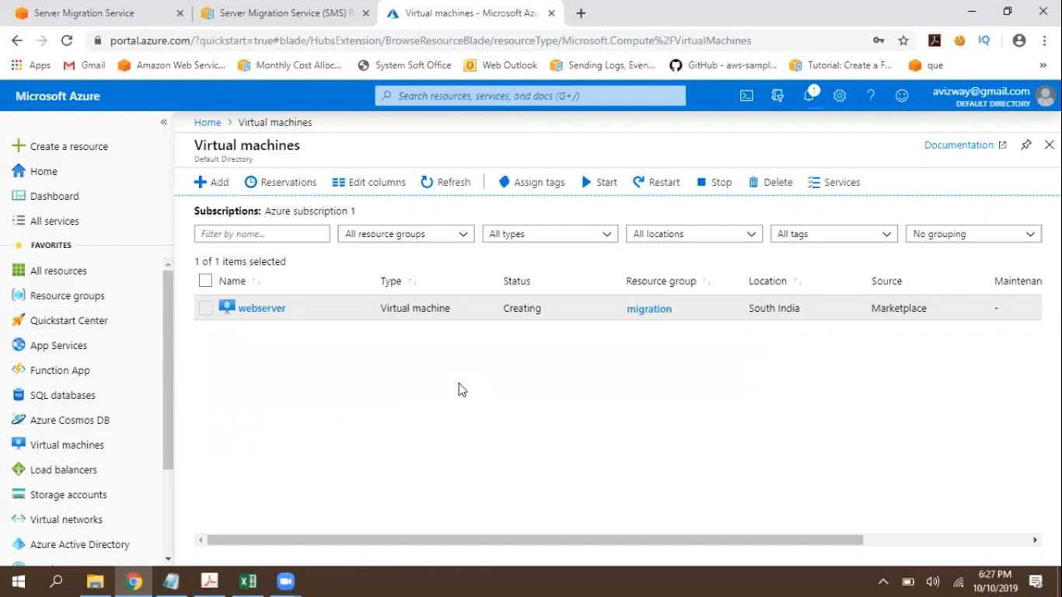 9 Your virtual machine has been created

**2- Provisioning the SMS virtual machine**

To provision your SMS virtual machine on Microsoft Azure, complete the following steps.

1. Download three PowerShell scripts listed under Step 1 of [**Installing the Server Migration Connection on Azure**](https://docs.aws.amazon.com/server-migration-service/latest/userguide/Azure.html).

|  |  |
| --- | --- |
| **File** | **url** |
| Installation script | [**https://s3.amazonaws.com/sms-connector/aws-sms-azure-setup.ps1**](https://s3.amazonaws.com/sms-connector/aws-sms-azure-setup.ps1) |
| MD5 hash | [**https://s3.amazonaws.com/sms-connector/aws-sms-azure-setup.ps1.md5**](https://s3.amazonaws.com/sms-connector/aws-sms-azure-setup.ps1.md5) |
| SHA256 hash | [**https://s3.amazonaws.com/sms-connector/aws-sms-azure-setup.ps1.sha256**](https://s3.amazonaws.com/sms-connector/aws-sms-azure-setup.ps1.sha256) |

2 .Before running the script for provisioning the SMS virtual machine, you must have an Azure Virtual Network and an Azure Storage Account in which you will temporarily store metadata for the tasks that SSM performs against the Microsoft Azure Subscription. A good recommendation is to use the same Azure Virtual Network as the Azure Virtual Machines being migrated, since the SSM virtual machine performs REST API communications to communicate with AWS endpoints as well as the Azure Cloud Service. It is not necessary for the SMS virtual machine to have a Public IP or Internet Inbounds Rules.

3. Run the installation script*.\aws-sms-azure-setup.ps1*

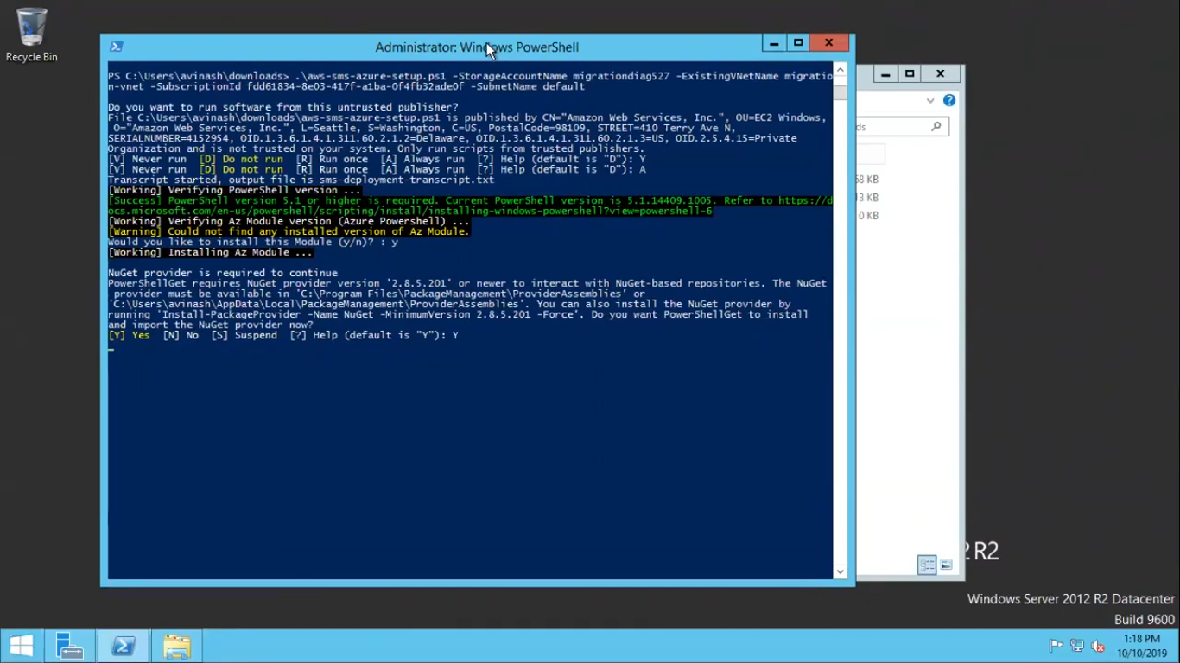

*4.The Microsoft Azure modules imports into the local PowerShell, and you receive a prompt for credentials to access the subscription.*

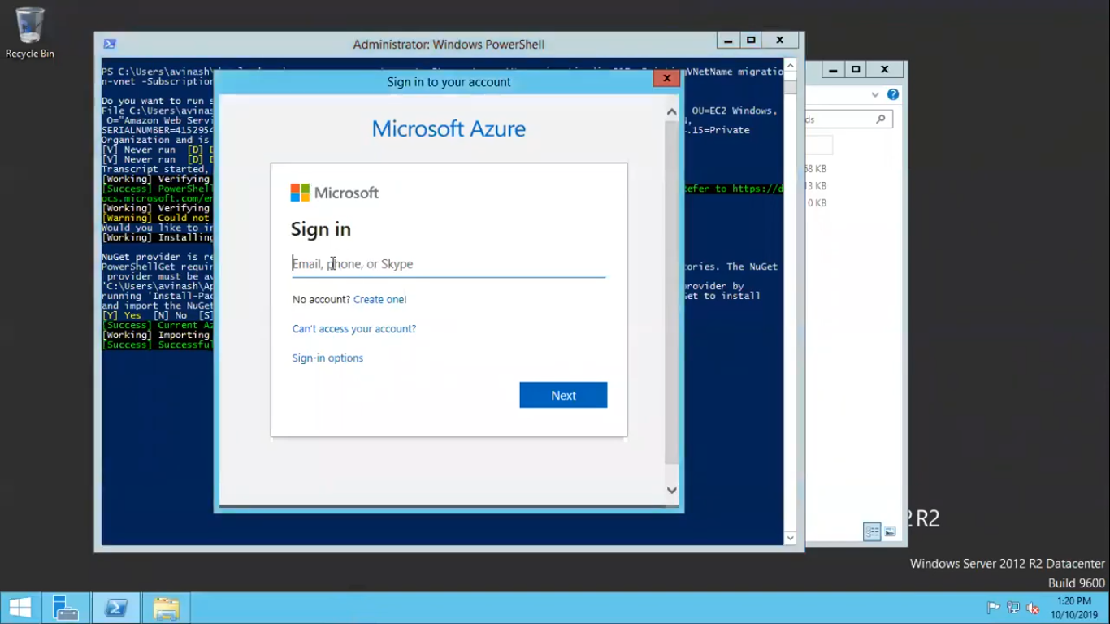 *5.A summary of the created features appears, similar to the following:*

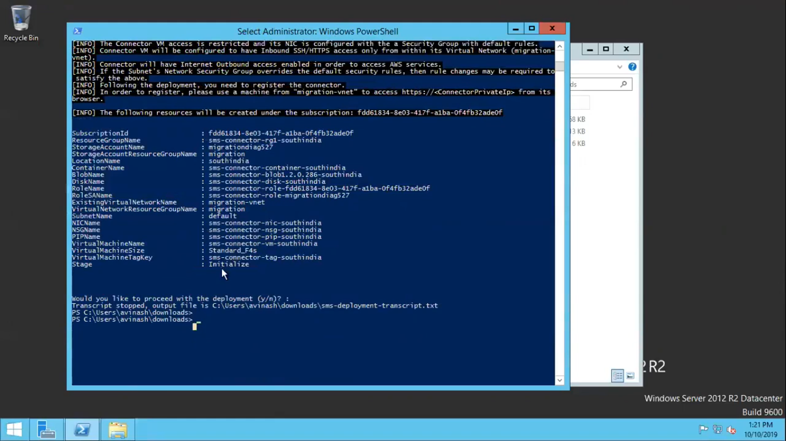

*6.Wait for the process to complete. It may take a few minutes:*

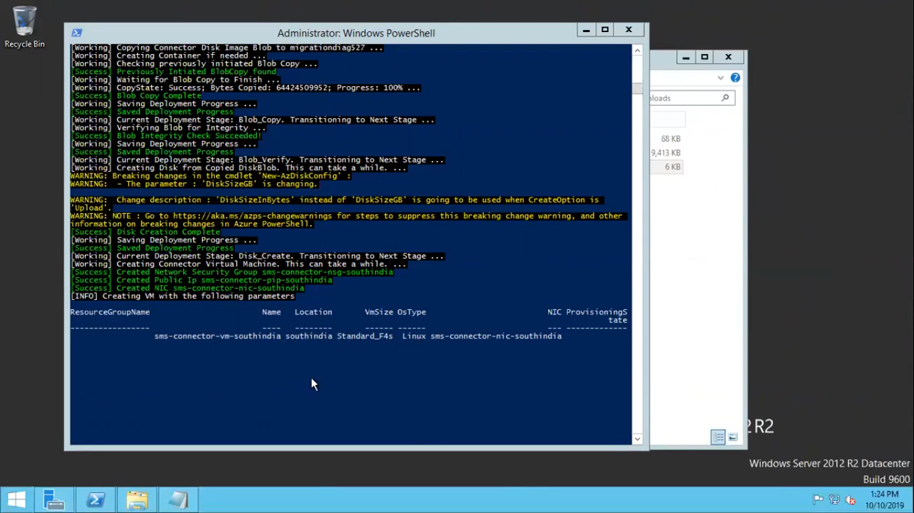

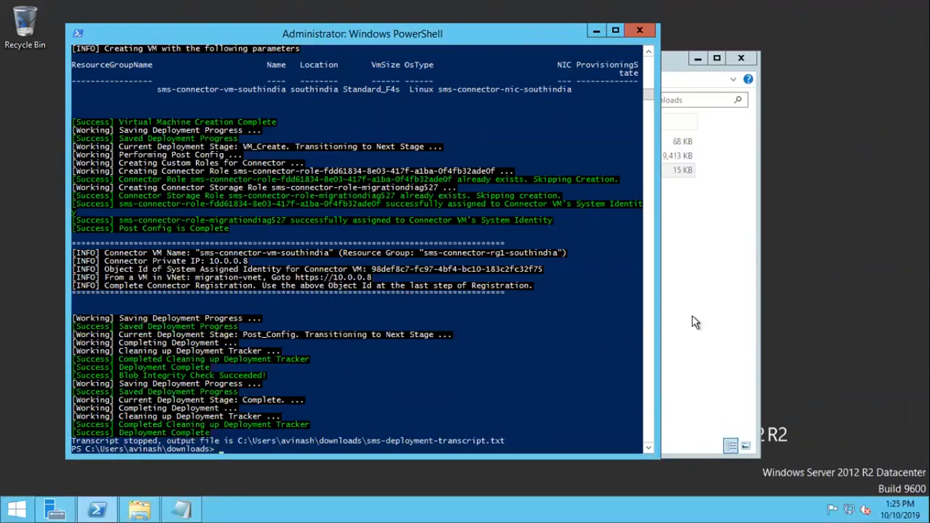

7.After the provisioning an output containing the Object Id of System Assigned Identity and Private IP. Save this information as it is going to be used to register the connector to the SMS service .

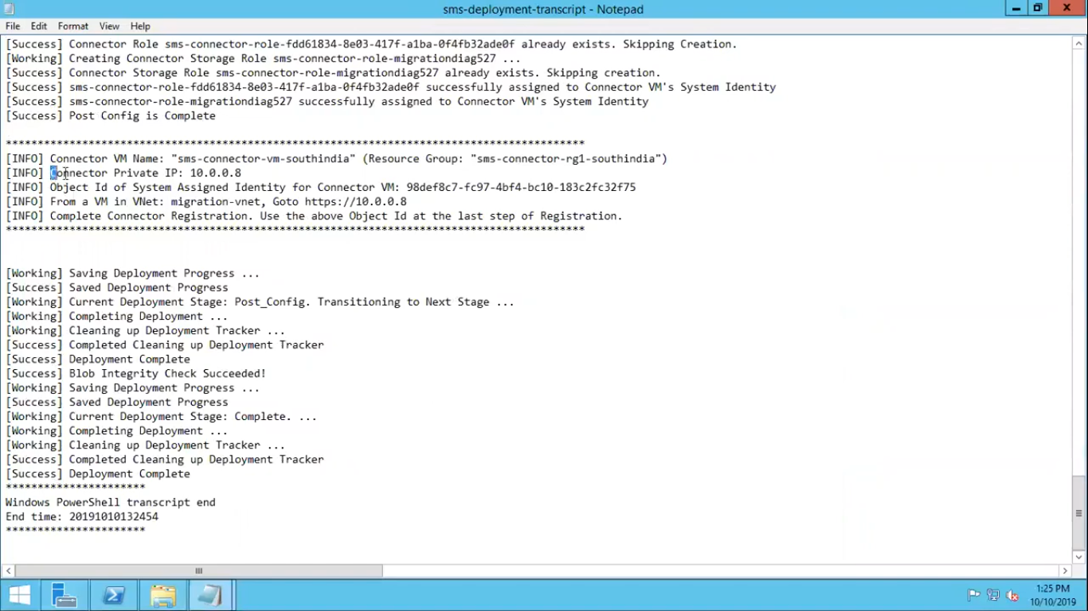

8.As a requirement, you need to create an IAM User that contains the necessary permissions for the SMS service to perform the migration. To do this, log into your AWS account at [**https://aws.amazon.com/console**](https://aws.amazon.com/console), under services select IAM. Then select User, and click Add user.

9.In the Add user page, insert a username and check the option Programmatic access. Click: Next Permissions.

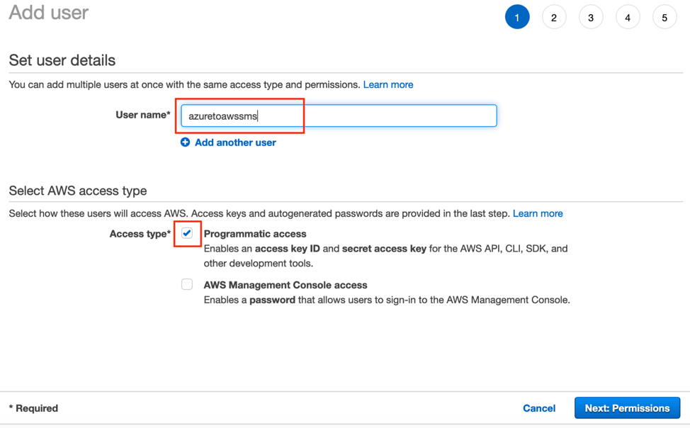

10.Attach an existing policy with the name ServerMigrationConnector. This policy allows the AWS Connector to connects and executes API-requests against AWS. Click Next:Tags.

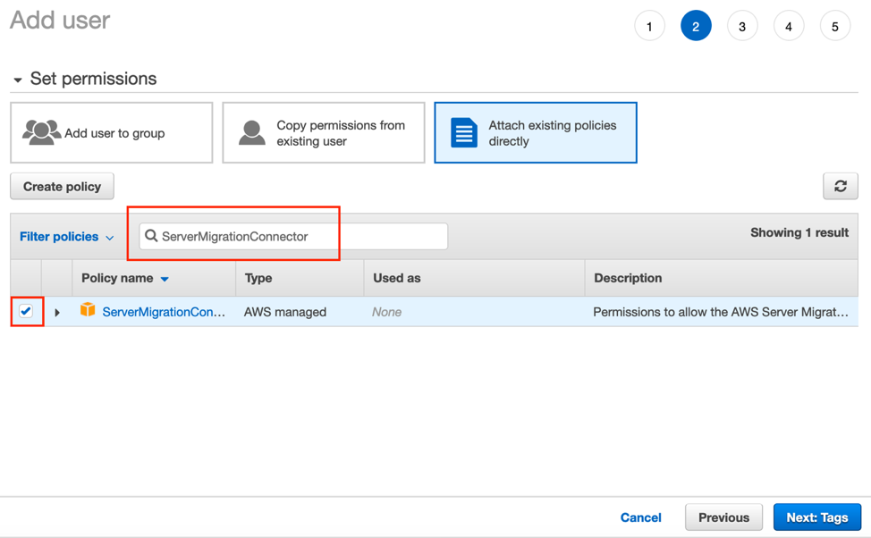

11. Click Create User and save the Access Key and Secret Access Key. This information is going to be used during the AWS SMS Connector setup.

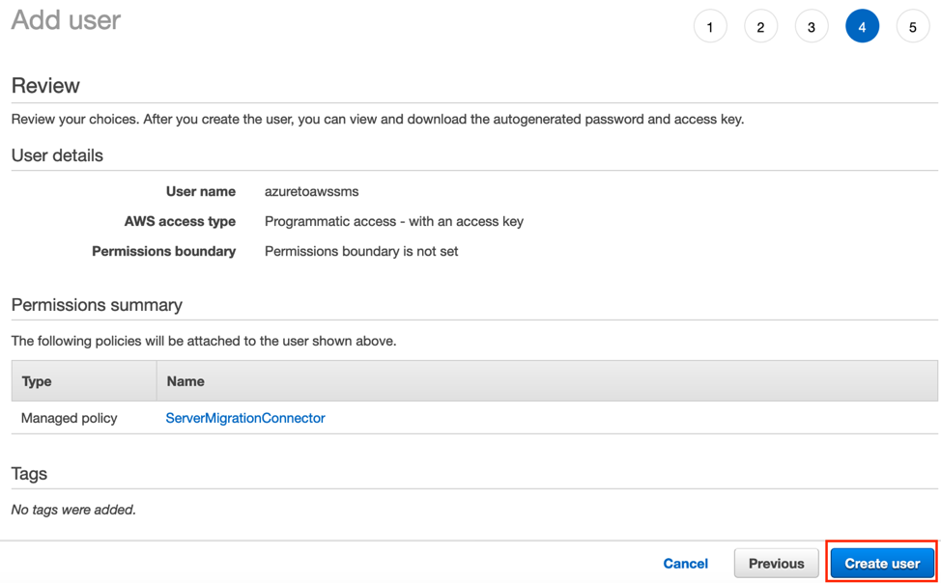

12.From a computer that has access to the Azure Virtual Network, access the SMS Virtual Machine configuration using a browser and the previously recorded private IP from the output of the script. In this example, the URL is [**https://10.0.0.8**](https://10.0.0.8/).

13.On the main page of the SMS virtual machine, click Get Started Now

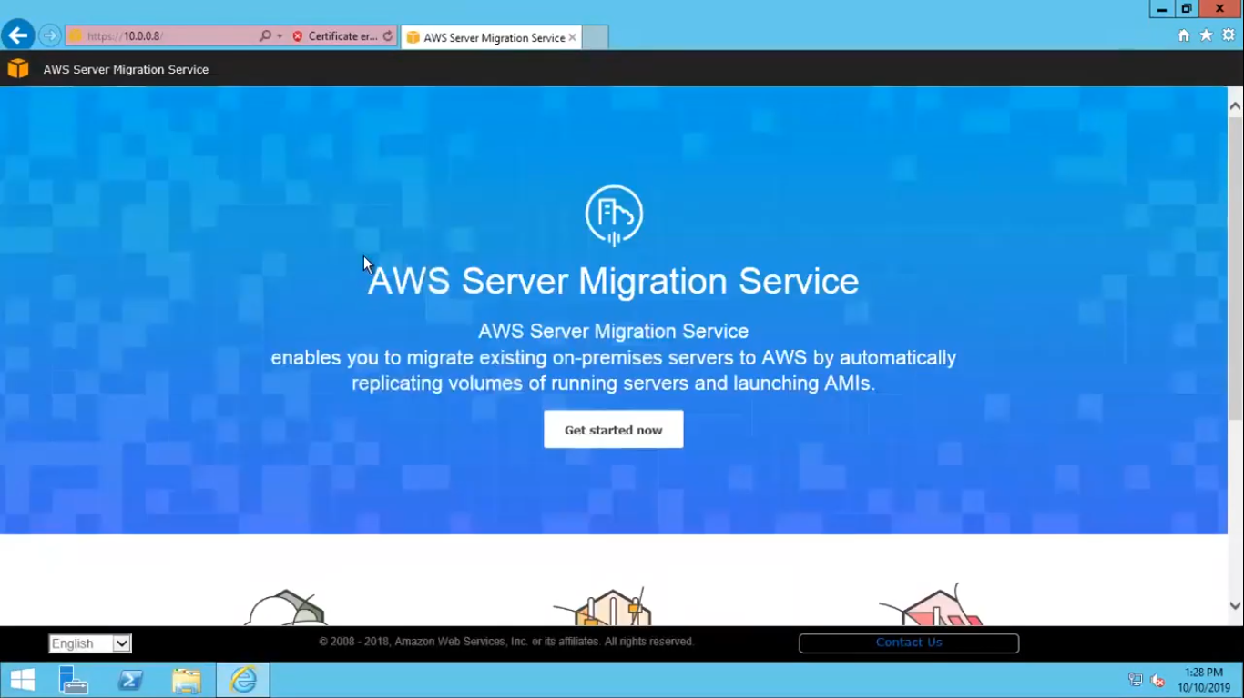  
14.Read and accept the terms of the contract, then click Next.

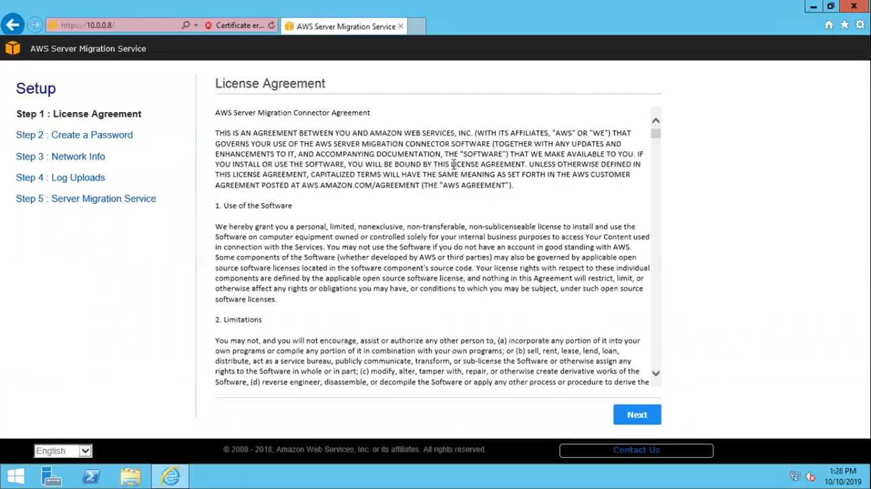

15. Create a password that will be used to login later in the management connector console and click Next.

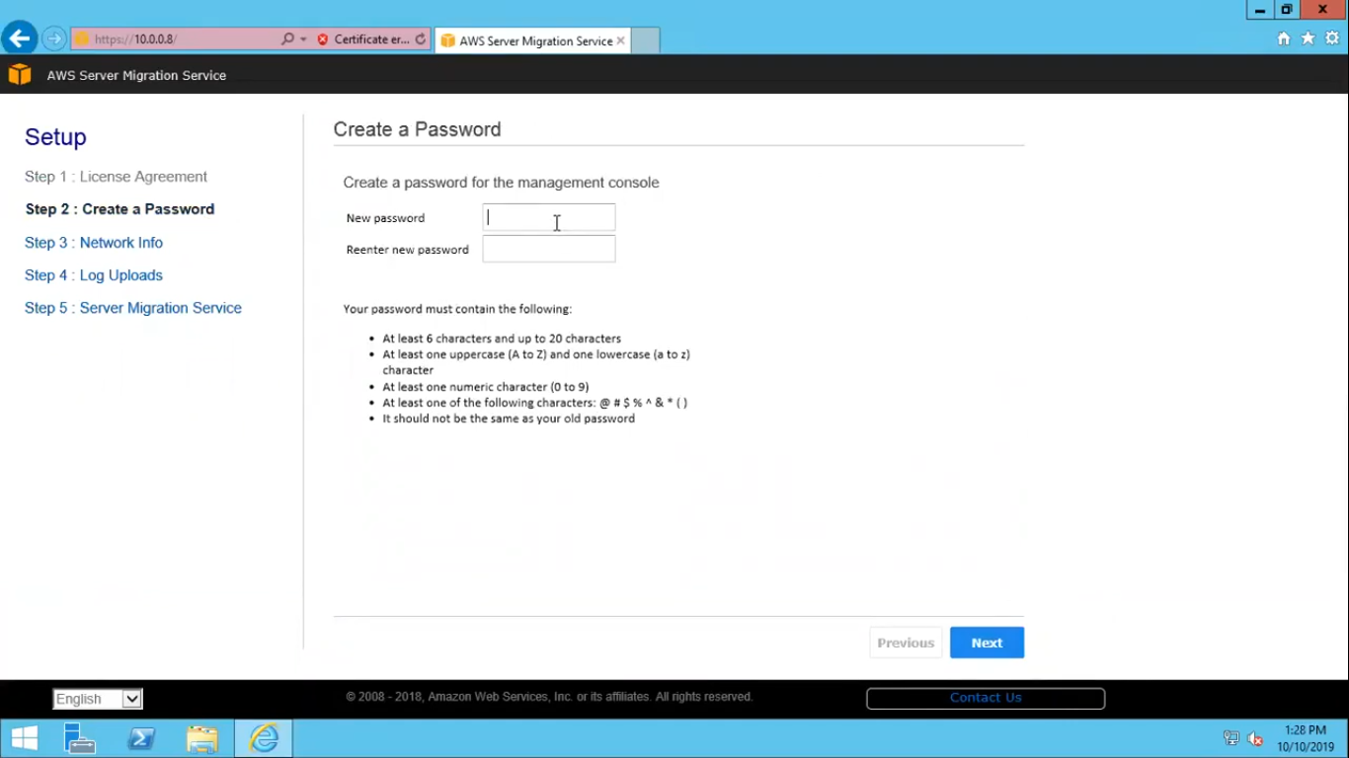

16.Review the Network Info and click Next.

17.Choose if you would like to opt-in to having anonymous log data set to AWS then click Next.

18. Insert an Access Key and Secret Access Key for an IAM User whose only policy is attached: “ServerMigrationConnector” Also, select the region in which the SMS endpoint will be used and click Next.

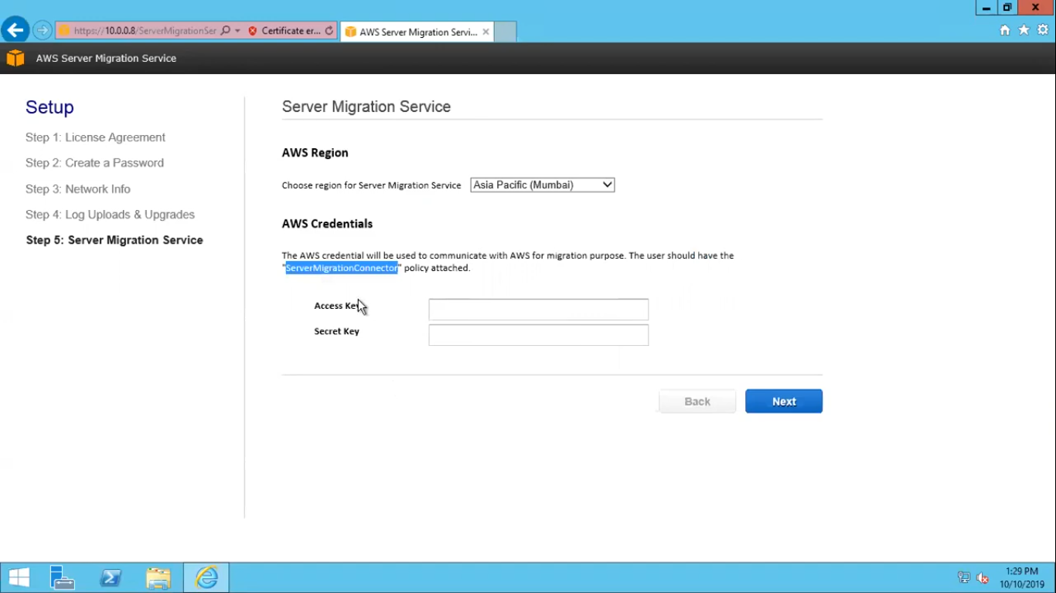

19. Enter the Object Id of System Assigned Identify copied in step 7 and click Next.

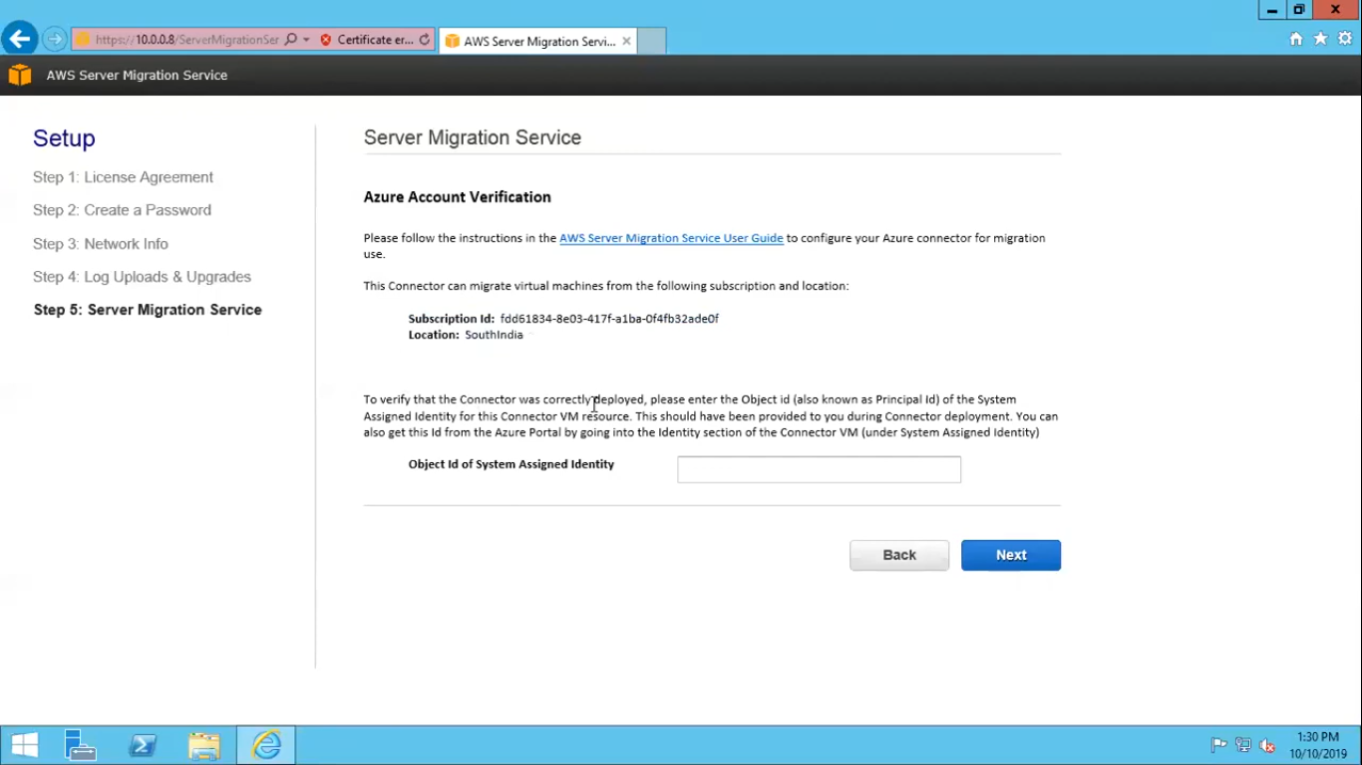

20.Congratulations, you have successfully configured the Azure connector, click Go to connector dashboard.

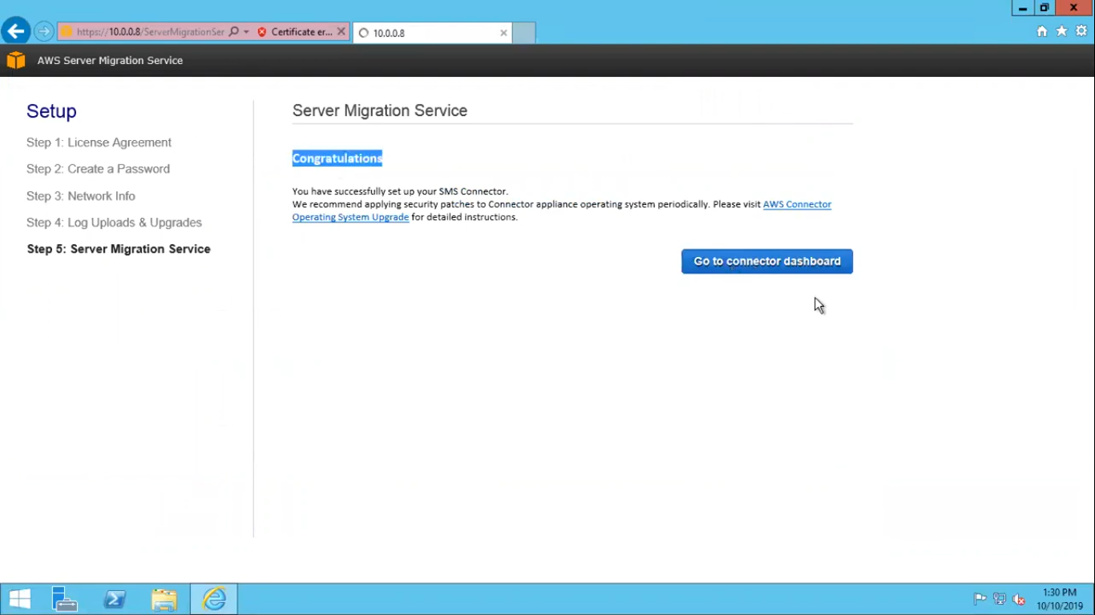

21.Verify that the connector status is HEALTHY by clicking Connectors on the menu.

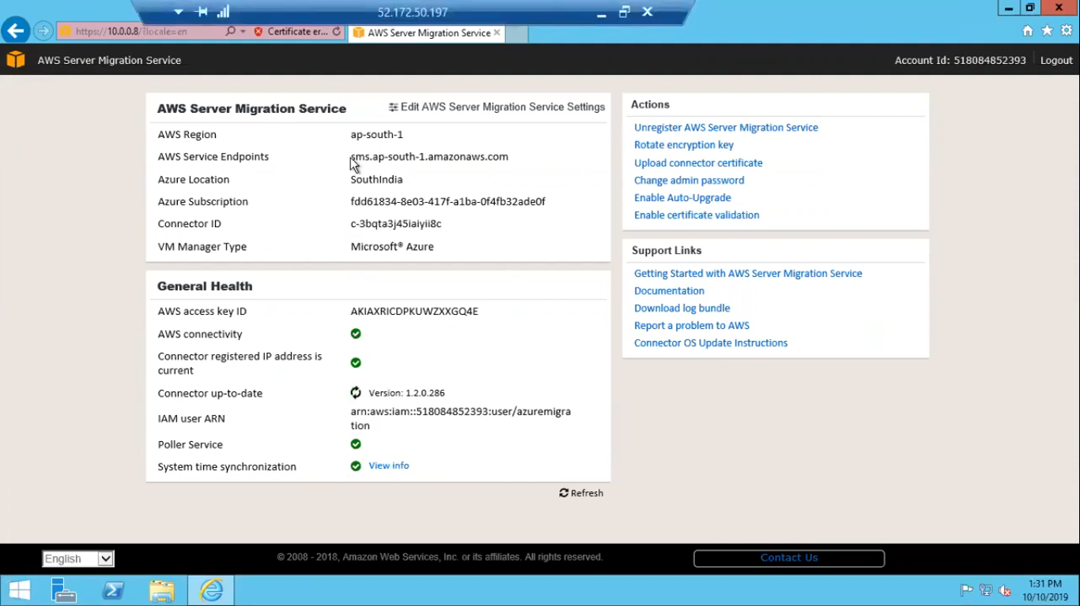

**2 – Replicating Azure Virtual Machines to Amazon Web Services**

1.Access the SMS console and go to the Servers option. Click Import Server Catalog or Re-Import Server Catalog if it has been previously executed.

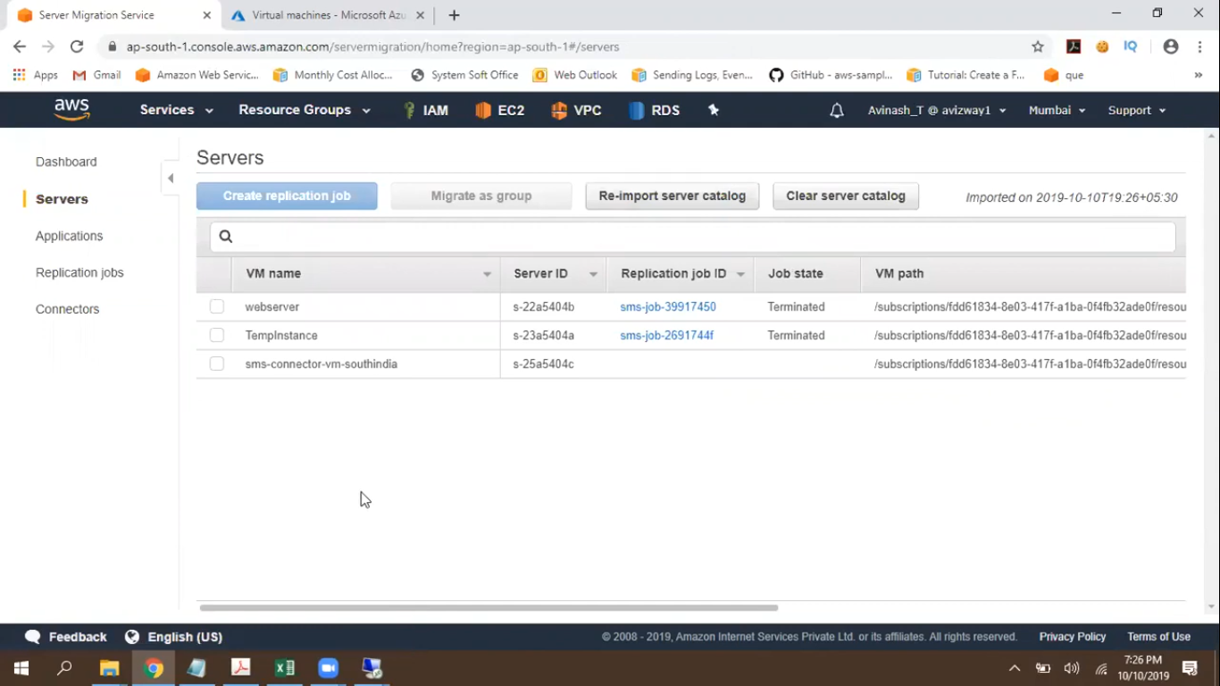

2.Select the Azure Virtual Machines to be migrated and click Create Replication Job.

3.Select which type of licensing best suits your environment, such as:

– Auto (we use in this project )

– AWS

– BYOL

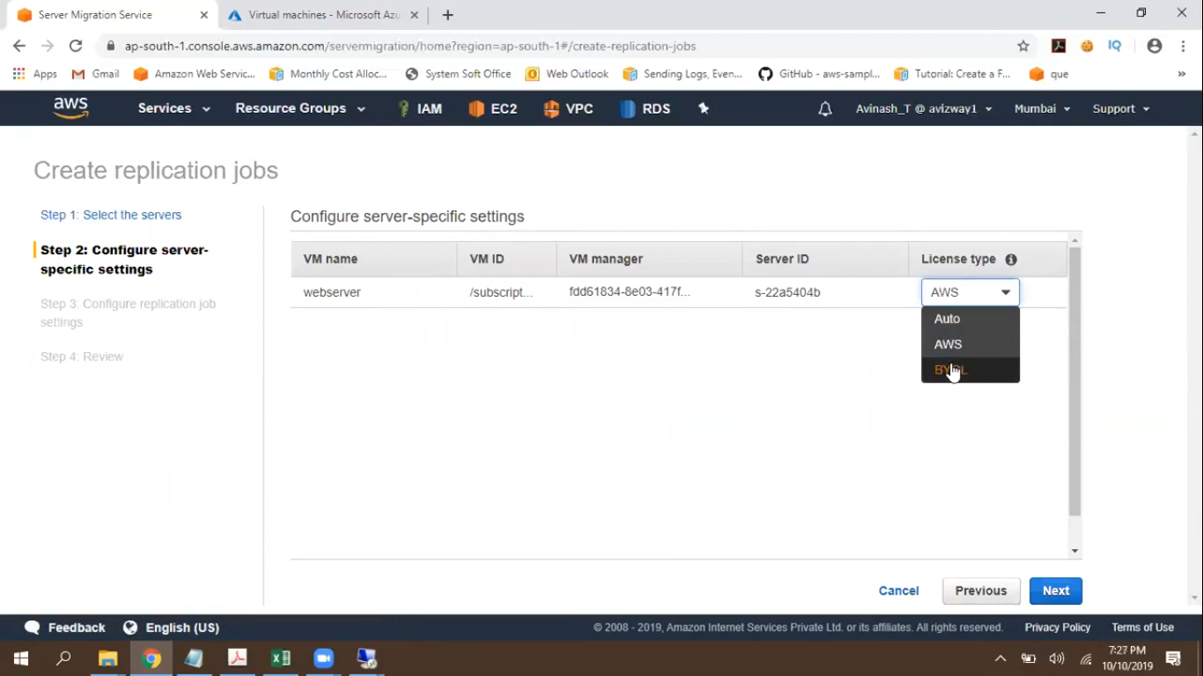

4.Select the appropriate replication frequency, when the replication should start, and the IAM service role. You can leave it blank and the SMS service is going to use the built-in service role “sms”

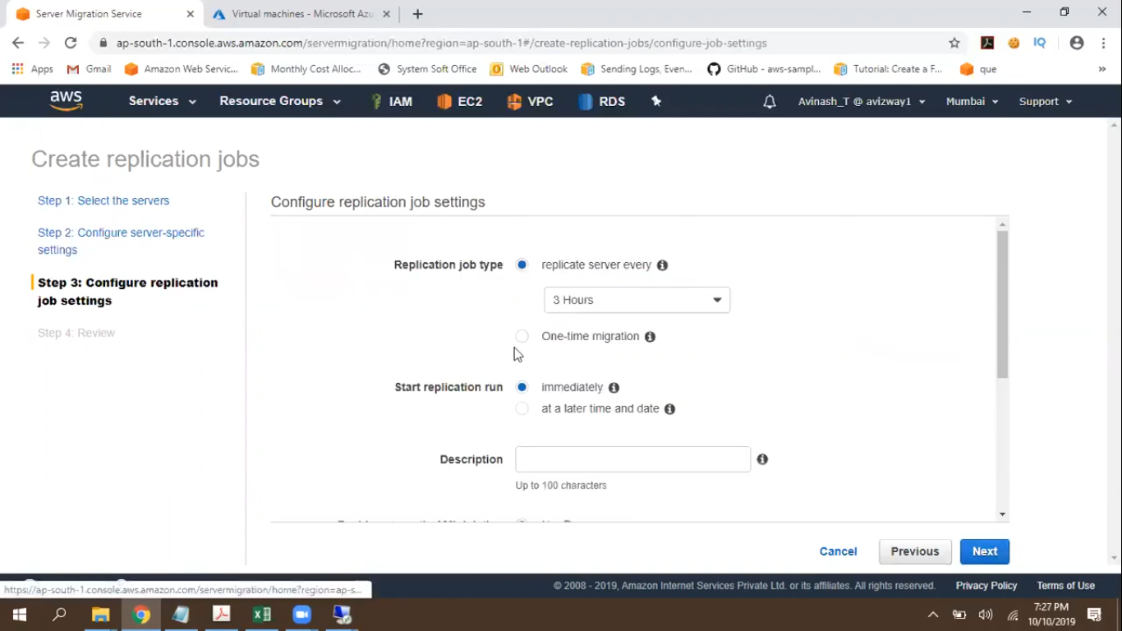

5.A summary of the settings are displayed and click Create.

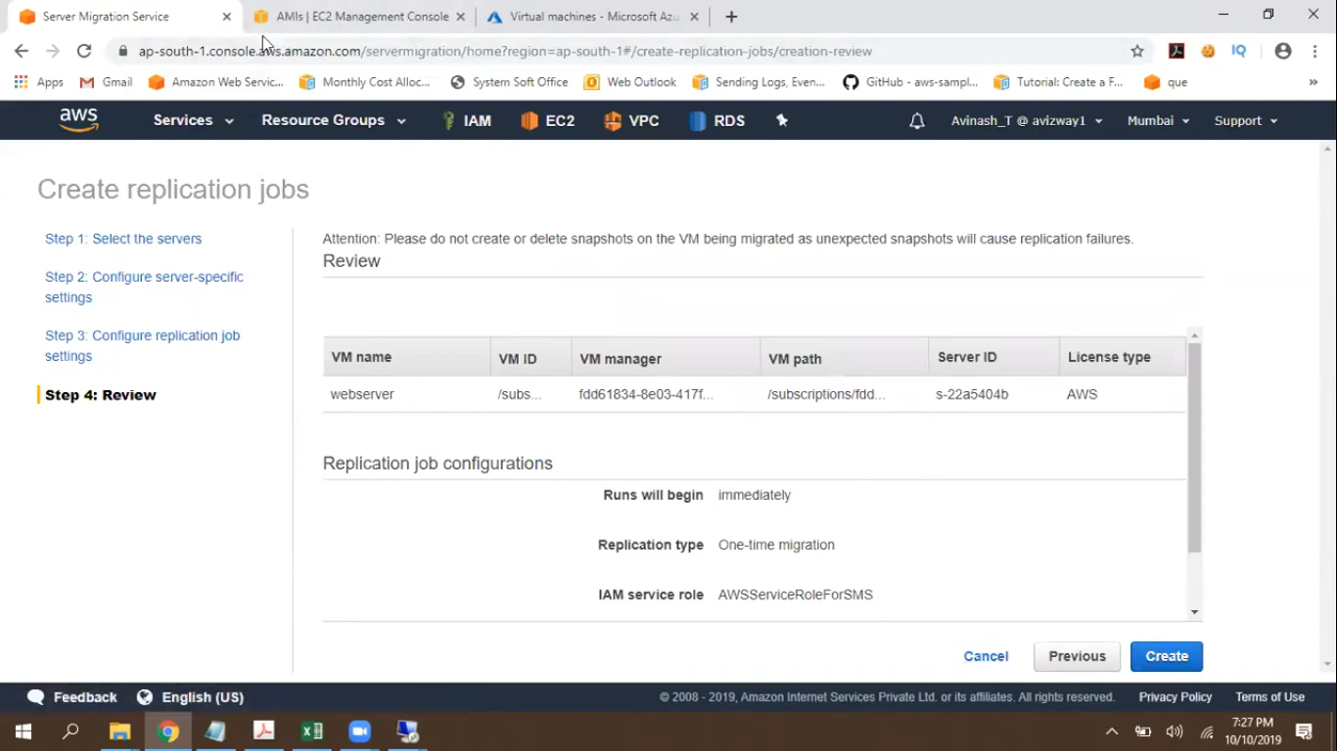

6.In the SMS Console, go to the Replication Jobs option and follow the replication job status:

7.After completion, access the EC2 console, go to AMIs, and a list of the AMIs generated by SMS will now be in this list. In the example below, several AMIs were generated because the replication frequency is 1 hour.

8.Now navigate to the SMS console, click Launch Instance and follow the screen processes for creating a new Amazon EC2 instance.

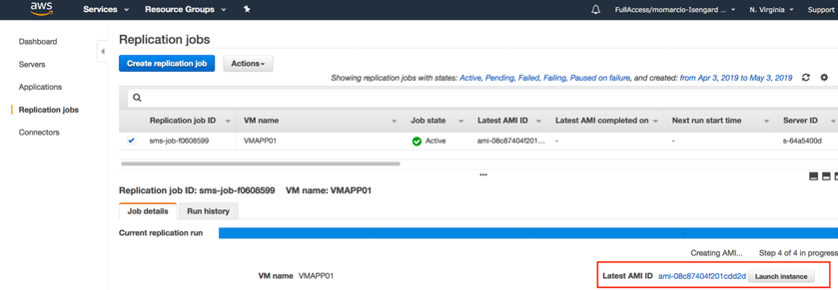Finally vm from azure is successfully migrated to aws using sms connector

**3.4 APPLICATIONS &** **LIMITATIONS :**

## Why Move from One Cloud to Another?

There are a number of reasons why a company would move from AWS to Azure or vice versa. In fact, before beginning a migration, some organizations looking ahead even require a transition-out plan as part of their cloud adoption strategies in case they ever need to move from their first cloud of choice.  
  
Reasons why users in Azure or AWS would want to switch to the competing cloud service provider include:  
  
**1. Changes in the terms and conditions**: Initial cloud adoption for enterprises often depends on a unique value proposition offered by a vendor. However, changes in the terms and conditions of a cloud service provider over time could lead to cloud lock-in concerns for organizations.  
  
**2. Application portability**: Another example of cloud lock-in possibility is the use of heterogeneous platforms used by different cloud vendors which can affect application portability. For example, workloads that use AWS community-contributed Amazon Machine Images (AMIs) or applications configured to make Amazon S3 API calls might limit the ability for enterprises to use other services outside of AWS. In such a case, it might be desirable to migrate out. Another lock-in example is how [Azure Site Recovery](https://cloud.netapp.com/blog/asr-migration-draas-solution) provides automated mechanisms for moving workloads from AWS to Azure, but requires multiple complex manual steps or third-party tools to migrate in the opposite direction.  
  
**3. Contract renewal**: Organizations often reevaluate hosting options during the contract renewal period to explore differentiating features offered by competing service providers. With new products and features being introduced by cloud service providers, customers have more choices than ever before to choose an optimal hosting platform for their applications.  
  
**4. Cost-benefits**: Services offered at premium rates by one service provider could be available at competitive rates with a different provider. For example, [Azure Hybrid Benefit](https://azure.microsoft.com/en-in/pricing/hybrid-benefit/) along with reserved instances can provide up to 80% cost saving and offers a great value proposition for organizations with pre-existing investments in Microsoft licenses. AWS, on the other hand, provides [Microsoft Licensing on AWS](https://aws.amazon.com/windows/resources/licensing/), in which customers can use their Microsoft licenses with or without [Software Assurance](https://www.microsoft.com/en-us/licensing/licensing-programs/software-assurance-default.aspx) to reduce cloud hosting charges.  
  
**5. Compliance standards**: [The compliance standards](https://cloud.netapp.com/blog/data-compliance-regulations-hipaa-gdpr-and-pci-dss) to be met for hosting data and application with a cloud service provider or on-premises varies across different industry sectors. Any instance of non-compliance flagged during an audit could lead to re-hosting or migration of application/data to a compliant platform.  
  
**6. Data consolidation**: In hybrid cloud architectures, a company’s data could exist across public/private clouds or on-premises deployments. Consolidation of data and seamless management is important for optimizing the spend on data storage and operations. One example of this is in the case of M&A (Mergers & acquisitions), where companies with different platforms need to consolidate.

## Cloud Migration Challenges between AWS and Azure

Data is the nexus of enterprise IT, and migration from AWS to Azure and vice versa is one of the most challenging aspects when implementing multicloud architectures. Let’s look at some of the challenges.  
  
**1. Data Migration**: The fact that AWS and Azure use proprietary storage offerings and APIs make the data migration process complex. Leveraging third party tools for data transfer could lead to integration challenges as both the platforms use diverse technologies in the backend. And the entire process of transitioning between the two clouds may not be a feasible option for business-critical applications due to time and cost constraints involved.  
  
**2. Secure Data Transfer**: Secure transfer of data between AWS and Azure should be done using a process that meets industry-specific governance and compliance standards. Direct download and upload of data can lead to security concerns as the data at rest and in transit should always be encrypted. While Azure Site Recovery offers a feasible solution for large scale secure migration between AWS and Azure, it requires additional infrastructure to be set up in AWS, which may not be feasible in cost-sensitive environments.  
  
**3. Access Control Privileges**: When data is migrated between AWS and Azure platforms, administrators need to ensure that consistent data access and protection policies are applied in the destination as well. Security and access control are configured using different sets of tools and policies in AWS and Azure. While AWS depends on IAM user policies and resource-based policies for Amazon S3 access, Azure storage uses RBAC assigned to Azure AD users. Hence, redesign and reconfiguration of the entire system might be required to maintain the same level of security after migration. Management of data across AWS and Azure environments using unified tools and interfaces is also a major challenge.  
  
**4. Other Challenges**: There are a few other additional challenges to the migration process between platforms. It will be necessary to find a way to evaluate the costs and calculate the differences. You’ll also need a way to measure and maintain the same or acceptable performance and SLAs of different devices, instances, VMs, storage types, etc. on the new platform.

**Poornima University, Jaipur** **B.tech, Computer Engineering(CT & IS)**

|  |  |
| --- | --- |
|  | **2019-20** |
|  |  |

**Chapter 4**

**Conclusion & Future scope**

**4.1 Conclusion:-**

AWS and Azure are the cloud service providers of choice for many enterprises. However, at some point after an initial Azure or AWS cloud migration, organizations may want to switch between service providers and perform a migration from AWS to Azure or from Azure to AWS. This can be due to many reasons, such as cloud lock-in, contract renewal, compliance requirements, and other use cases we’ve discussed in this blog.  
  
Flexibility of tools and solutions that can be used across both AWS and Azure platform are crucial for a hassle-free migration experience with minimal time and effort.

**4.2 Future scope**



* + Your application is experiencing **increased traffic** and it’s becoming difficult to **scale resources on the fly** to meet the increasing demand.
  + You need to **reduce operational costs** while increasing the effectiveness of IT processes.
  + Your clients require fast application implementation and deployment and thus want to focus more on development while **reducing infrastructure overhead.**
  + Your clients want to expand their business geographically, but you suspect that **setting up a multi-region infrastructure** – with all the associated maintenance, time, human, and error control effort – is going to be a challenge.
  + It’s becoming more difficult and expensive to keep up with your **growing storage needs**.
  + You’d like to build**a widely distributed development team**. Cloud computing environments allow remotely located employees to access applications and work via the internet.
  + You need to establish a disaster recovery system but setting it up for an entire data center could double the cost. It would also require a complex disaster recovery plan. Cloud disaster recovery systems can be implemented much more quickly and give you much better control over your resources.
  + **Tracking and upgrading underlying server software** is a time consuming, yet an essential process that requires periodic and sometimes immediate upgrades. In some cases, a cloud provider will take care of this automatically. Some cloud computing models similarly handle many administrative tasks such as database backup, software upgrades, and periodic maintenance.
  + Capex to Opex: Cloud computing shifts IT expenditure to**a pay-as-you-go model,** which is an attractive benefit, especially for startups.



**Poornima University, Jaipur** **B.tech, Computer Engineering(CT & IS)**

|  |  |
| --- | --- |
|  | **2019-20** |
|  |  |

**REFERENCES**

The References taken for the development of this report and Project are:

[www.Checkspoint.com](http://www.tutorialspoint.com/)

<https://www.futureofeverything.io/future-vpns/>

<https://docs.microsoft.com/en-us/azure/vpn-gateway/vpn-gateway-certificates-point-to-site-linux>

<https://docs.microsoft.com/en-us/azure/vpn-gateway/vpn-gateway-howto-point-to-site-resource-manager-portal>

<https://hamersmithblog.wordpress.com/2017/06/30/connecting-web-apps-to-external-services-point-to-site-vpn-walkthrough/>

[https://docs.microsoft.com/en-us/azure/storage/files/storage-files-configure-p2s-](https://docs.microsoft.com/en-us/azure/storage/files/storage-files-configure-p2s-vpn-linux)

[vpn-linux](https://docs.microsoft.com/en-us/azure/storage/files/storage-files-configure-p2s-vpn-linux)<https://github.com/MicrosoftDocs/azure-docs/blob/master/articles/vpn-gateway/point-to-site-vpn-client-configuration-azure-cert.md>

www.youtube.com

Avolio, F. M. and Ranum, M. J. 1994. A network perimeter with secure external access. In Internet Society Symposium on Network and Distributed Systems Security, 3-4 Feb. 1994, San Diego, CA, USA. Internet Society, Reston, VA, USA, 109–119.

http://www.ja.net/CERT/Avolio_and_Ranum/isoc94.ps Accessed 2002 Feb 20. Axelsson, S. 1998. Research in Tunnel Generation and Key Formation using Certificates: A survey. Tech. Rep. 98–17, Dept. of Computer Eng. Chalmers Univ. of Tech, SE-412 96 G¨oteborg, Sweden. December.

http://www.ce.chalmers.se/staff/sax/survey.ps Accessed 2002 Feb 20. Bailey, M. L., Gopal, B., Pagels, M. A., Peterson, L. L., and Sarkar, P. 1994. PATHFINDER: Change in Privacy Industry

In 1st Symposium on VPN and their importance, 14-17 November 1994, Monterey, CA, USA. USENIX Association, Berkeley, CA, 115–123

[**http://etd.fcla.edu/etd/uf/2000/ana6124/Master.**](http://etd.fcla.edu/etd/uf/2000/ana6124/Master.pdf)

[**https://docstore.mik.ua/univercd/cc/td/doc/product/iaabu/centri4/user/scf4ch3**](https://docstore.mik.ua/univercd/cc/td/doc/product/iaabu/centri4/user/scf4ch3.pdf)

[**https://www.juniper.net/documentation/en_US/learn-about/P2SEvolution**](https://www.juniper.net/documentation/en_US/learn-about/LA_FIrewallEvolution.pdf)

**Poornima University, Jaipur** **B.tech, Computer Engineering(CT & IS)**